In Azure Synapse Analytics, we will use spark pool. Spark pool is useful to run the code and perform the data transformations and data processing whatever we want to call.

In Azure Databricks, we use clusters, create a notebook, will write code in notebook and this code we will run on cluster. This code from a notebook we are running on a spark pool. There is Apache spark which we installed on cluster. Apache Spark is like software/computing engine/run time that will help us to perform bigdata processing which means that if we want to process big data in a rapid speed manner, then we can use this Apache spark engine.

Our data is available in files or some storage accounts, we want some kind of run time engine to process /query that big data. Apache Spark will help us to write queries on top of big data data sets and process the data according to our needs and load the data into destination data warehouses or into some systems. Apache spark has developed few API’s for the spark to interact. because of this we can write Scala, python, SQL, R codes inside a notebook to interact with spark. this is happening because of pyspark.

Pyspark is nothing but like a python libraries, that interact with spark for our data processing.

**Spark Architecture:** If our data is from streaming platforms, we can use spark to analyze it or to process it. we can build a machine learning pipelines also on top of it. Spark SQL Data frame capabilities help us to process data using spark on big data data sets

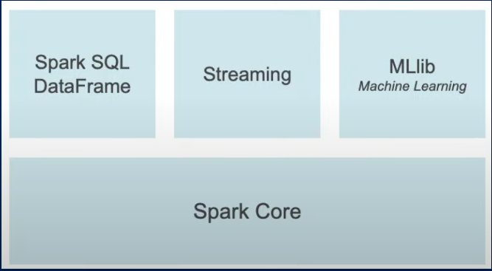

**Pyspark is python libraries to interact with big data data sets and then perform transformations according to our needs.**

**DATA FRAME:** Data frame is a distributed collection of data organized in to named columns.  **Data frame is like table, we are reading data from some storage and storing the data in table within a memory.** Once we get data in data frame, we will apply some transformations and load the data back.

**TYPE FUNCTION:** Type function is to know data type or type behind any object/value or data.

**Type(spark)** op: pyspark.sql.session.SparkSession spark is an object

**Type(‘abcd’**) op: str

**DIR FUNCTION:** Dir function will give us all methods /functions and the list of properties/attributes available on top of that object.

**dir(spark)**

**HELP FUNCTION: help(spark. createDataFrame)**

This help function will tell us syntax of createDataFrame method and return us output (:class: ‘DataFrame’)

**CREATEDATAFRAME FUNCTION:**  will create data frame object.

Tuple means () collection of items . every item is of different types. In the below example the first item inside a tuple is an integer type and 2nd item is a string type. Below example has 2 tuples.

[] 🡪 list of values

E.g.: **data =[(1,’Sravs’),(2,’anthi’)]** list with 2 tuples is created

**df= spark.createDataFrame(data)** 🡪 created data frame we are storing it in df variable)

**SHOW FUNCTION:** df.show() 🡪 show function is used to show data inside a data frame.

-1 -2

o/p: 1 Sravs

2 anthi

Here column names is 1 and 2 no column name there because we haven’t mentioned schema there. Schema is nothing but structure to the data frame like column names and column data types.

Syntax: **df= spark.createDataFrame(data,schema)**

**df= spark.createDataFrame(data,[‘id’,’name’])**

**df.show()** 🡪 now column headers was shown after adding schema in syntax .

id name

o/p: 1 Sravs

2 anthi

**printSchema Function:** printSchema function will give us schema of the data frame.

**df.printSchema()**

o/p: id: long(nullable=true)

name: string (nullable=true)

we haven’t mentioned data type while creating data frame. by default, pyspark is automatically taking id as long and name as string.

**StructType FUNCTION:** StructType will create our own schema( new data type) where we can define our own structure. To create every field, we will make use of StructField .

we haven’t mentioned data type while creating data frame. by default, pyspark is automatically taking id as long and name as string. Now I don’t want id as long data type, I need id column as int, that we can change column data types by using struct type function will show in below example.

**Help(StructType) 🡪 will get syntax of StructType .**

**Help(StructField) 🡪 will give syntax of struct field.**

Syntax: StructField(name=,dataType=,nullable=True, metadata=None)

Eg: **from pyspark.sql.types import * --importing all data types, integer type string type etc)**

**data= [(1,’sravs’),(2,’anthi’)]**

**schema = StructType([StructField(’id’ , IntegerType()),**

**StructField(’name’,StringType())])**

**df=spark.createDataFrame(data,schema)**

**df.printSchema()**

o/p: id: integer (nullable = true)

name: string (nullable =true)

**CREATING DATA FRAME DATA WITH DICTITIONARY DATA-KEY VALUE PAIRS:**

**data =[{‘id’: 1,’name’: ’sravs’},**

**{‘id’:2,’name’ : ‘anthi’}]**

**df= spark.createDataFrame(data)**

**df.show()**

**df.printSchema()**

o/p: id: long(nullable=true)

name: string (nullable=true)

**READ 1CSV FILE /MULTIPLE CSV FILES/ALL CSV FILES IN FOLDER INTO DATA FRAME USING PYSPARK:**

**help(spark.read)**

DataFrameReader is a class contains read object .in that object csv method or format().load() method that will help us to read csv files.

**Note: HOW DBFS FILE SYSTEM IS ENABLED:**

Go to Settings (mail id) at RHS 🡪 Go to Admin Console 🡪 Go to workspace settings 🡪 enable DBFS file system. Now DBFS tab will appear in Data menu.

Now go to Data 🡪 DBFS tab 🡪 double click FileStore🡪 right click and create folder Data and upload files of local files (Employees1.csv and Employee2.csv).

df=spark.read.csv(path=’dbfs:/FileStore/data/Employees1.csv’) --here file path is Employees1.csv file path we copied from DBFS file system path.

**display(df) 🡪 can display data frame result**

o/p:

c0 c1 c2 c3

1 id name gender salary

2 1 maheer male 1000

3 2 pradeep male 2000

Here column names came as c0, c1,c2,c3 instead of id, name, gender, and salary so we need to keep header=true as shown below.

**df=spark.read.csv (’dbfs:/FileStore/data/Employees1.csv’ , header=True)**

o/p: id name gender salary

1 1 maheer male 1000

2 2 pradeep male 2000

**df.printSchema()**

o/p: c0 : string (nullable=true)

c1 : string (nullable=true)

c2 : string (nullable=true)

c3: string (nullable=true)

In CSV file, every column will come as a string only automatically.

We can also read csv files in another way as shown below.

**df= spark.read.format(‘csv’).option(“header”,True).load(’dbfs:/FileStore/data/Employees1.csv’)**

In our csv file, if separator is not comma, then we need to keep sep= ‘|’)

**df=spark.read.csv (’dbfs:/FileStore/data/Employees1.csv’ , header=True, sep= ’|’)**

**help(spark.read.csv)** --this will show us what are different methods available with spark.read.csv

**HOW TO READ MULTIPLE CSV FILES FROM DIFFERENT PATH FILES:**

**df=spark.read.csv([’dbfs:/FileStore/data/Employees1.csv’, ’dbfs:/FileStore/data1/Employees2.csv’],header=True) -- here data and data1 are folders .**

All paths of csv file we will pass it as a list , if schema is same for all the files, then automatically our data frame will create without any issues.

**display(df)**

id name gender salary

1 1 maheer male 1000

2 2 pradeep male 2000

3 3 wafa male 3000

4 4 sarfarai male 4000

**READING ALL CSV FILES IN A FOLDER:**

**df= spark.read.csv(‘dbfs:/FileStore/data/’,header=True) --this will read all files which are there in data folder.**

o/p: id: string (nullable=true)

name: string (nullable=true)

gender: string (nullable=true)

salary: string (nullable=true)

If I want to change id and salary to integer type I can do that via below query.

**from pyspark.sql.types import \***

**schema = StructType().add(‘id’,IntegerType())\**

**.add(‘name’,StringType())\**

**.add(‘gender’,StringType())\**

**.add(‘salary’, IntegerType())**

**df= spark.read.csv(‘dbfs:/FileStore/data/’,schema=schema, header=True)**

**df.printSchema()**

o/p: id: integer (nullable=true)

name: string (nullable=true)

gender: string (nullable=true)

salary: integer (nullable=true)

**WRITE DATAFRAME INTO CSV FILE USING PYSPARK:**

In PySpark, the **write** method is a part of the DataFrame Writer API, which is used to save the data from a DataFrame to various external data storage systems (DBFS/data bases/ADLS) and formats. The **write** method is typically used with various formats, modes, and options to configure how the data should be written.

**from pyspark.sql import dataframe**

**help(dataframe.DataFrame.write) 🡪 first dataframe is module, 2nd data frame is class, write is function.**

**data= [(1,’sravs’),(2,’anthi’)]**

**schema= [‘id’,’name’]**

**df=spark.createDataFrame(data,schema)**

**type(df.write) 🡪 it is of DataFrameWriter type.**

**Help(df.write.csv) 🡪 this will tell us brief documentation about csv parameters like mode, sep,**

**Different saving modes:**

**Append:** Will add contents to existing data.

**overwrite:** if destination path already exists, it will overwrite existing data.

**Ignore:** If the destination path already exists, no action is taken, and the write operation is ignored. This is useful when you want to avoid overwriting or appending to existing data and only write if the path does not exist.

**Error:** If the destination path already exists, this mode raises an error, and the write operation fails. It is useful when you want to ensure that the destination is always a new, empty location, and an error should be raised if it's not.

**df.write.csv(‘dbfs:/tmp/emps’, header=True) --here tmp and emps are folders, in emp folder file created as shown below.**

Here 3 csv files are shown as highlighted below in yellow colour. Why this happens means in spark we are having driver node which is at top, and worker nodes behaves as slaves. Under driver nodes, many worker nodes will be there. If driver node has 3 worker nodes means All 3 worker nodes will take the data by partitioning into 3 partitions and we will process the data and finally it will store every processed data that means every partition data has a separate path file

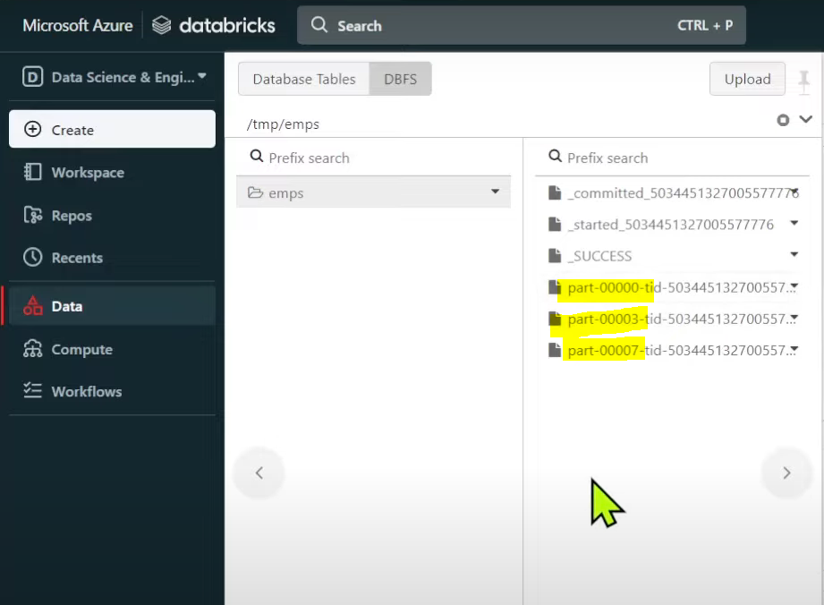

If I want to get all 3 csv part files in to single file with single file name like employees.csv we can do it by repartition function.

**display(spark.read.csv(‘dbfs:/tmp/emps’, header=True)**

if we use below query with mode=’error’ or mode=’’ we will get error as directory is already exists.

**df.write.csv(‘dbfs:/tmp/emps’, header=True, mode=’error’)**

o/p: dbfs:/tmp/emps already exists.

If we don’t want to get this error dbfs:/tmp/emps already exists, we can use mode = ‘ignore’

**df.write.csv(‘dbfs:/tmp/emps’, header=True, mode=’ignore’)** 🡪 If path is already there, it will simply ignore the execution.

**df.write.csv(‘dbfs:/tmp/emps’, header=True, mode=’append’)**

**display(spark.read.csv(‘dbfs:/tmp/emps’, header=True))**

|  |  |  |
| --- | --- | --- |
|  | id | name |
| 1 | 1 | sravs |
| 2 | 1 | sravs |
| 3 | 2 | anthi |
| 4 | 2 | anthi |

**df.write.csv(‘dbfs:/tmp/emps’, header=True, mode=’overwrite’)** 🡪 in df we are having 2 rows , so 4 rows will be deleted and it will overwrite data of df variable. Now output will be

|  |  |  |
| --- | --- | --- |
|  | id | name |
| 1 | 1 | sravs |
| 2 | 2 | anthi |

**READ 1 JSON FILE/MULTIPLE JSON FILES/ALL JSON FILES FROM A FOLDER INTO DATAFRAME USING PYSPARK:**

Examples of single line JSON vs Multi-line JSON:

**Single line JSON:** consisting of 2 objects , each object has different fields with key value pairs.

[{"name":"John","age":30,"city":"New York"}, {"name":"Alice","age":25,"city":"Los Angeles"}]

**Multi line JSON:**

[

{

"name": "John",

"age": 30,

"city": "New York"

},

{

"name": "Alice",

"age": 25,

"city": "Los Angeles"

}

]

**READING SINGLE_LINE JSON FILE INTO DATAFRAME:**

**df=spark.read.json(‘dbfs:/FileStore/data/emps.json’) 🡪 single line file emps.json**

**df.printSchema()**

**df.show()**

**READING MULTI_LINE JSON FILE INTO DATAFRAME:**

**df=spark. read.json(‘dbfs:/FileStore/data/empsML.json’, multiLine=True)** 🡪 for multi-line json file if we won’t keep multiLine=True in syntax we will get error as corrupted file.

**HOW TO READ MULTIPLE JSON FILES FROM DIFFERENT FOLDER PATHS /SAME FOLDER PATHS WITH SAME SCHEMA:**

**df= spark.read.json([‘dbfs:/FileStore/data/emps1.json’ , ‘dbfs:/FileStore/data1/emps2.json’])**

**READ ALL JSON FILES IN A FOLDER:**

**df = spark.read.json(‘dbfs:/FileStore/data/*.json’)** 🡪 this will read all json files from data folder . data folder also contains csv files too. if we keep *. json, we will get only json files even if there are csv files.

If I want to change data types for few fields, we can do this via below query.

**From pyspark.sql.types import \***

**schema= StructType().add(‘id’,IntegerType())\**

**.add(‘name’,StringType())\**

**.add(‘gender’,StringType())\**

**.add(‘salary’,IntegerType())**

**df= spark.read.json(‘dbfs:/FileStore/data/*.json’ ,schema=schema)** 🡪 now this schema will be applied on top of data frame.

**df.printSchema()** -> now id and salary are changed to data type of integer.

**WRITE DATAFRAME INTO JSON FILE USING PYSPARK:**

**data= [(1,’sravs’),(2,’anthi’)]**

**schema= [‘id’,’name’]**

**df=spark.createDataFrame(data,schema)**

**help(df.write)**

**df.write.json(‘dbfs:/FileStore/jsondata/emps.json’) 🡪 jsondata is folder and emps.json also created as folder instead of file as shown below screenshot. When we are writing data, driver node divides work into worker nodes. And each worker node will take data in partitions and below screenshot shows data in 3 partitions.**

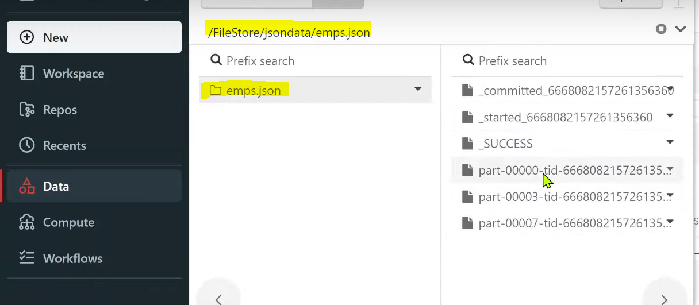

**df.write.json(‘dbfs:/FileStore/jsondata/emps’)**

**display(spark.read.json(‘dbfs:/FileStore/jsondata/emps’)) -> emps is folder and in emps folder files was placed.**

**Similarly we will use mode methods here too**

**df.write.json(‘dbfs:/FileStore/jsondata/emps’ , mode =’append’)**

**READING PARQUET FILES INTO DATA FRAME USING PySpark:**

help(spark.read.parquet)

df=spark.read.parquet(‘dbfs:/FileStore/data/userdata1.parquet’) 🡪 In FileStore folder 🡪 data folder 🡪 userdata1.parquet file got saved. We are saving this entire result into data frame(df).

df.count() 🡪 This function will give count of rows of a data frame and the value will be returned in a int format

print(df.count())

**READING ALL PARQUET FILES INTO DATA FRAME USING PySpark:**

**df=spark.read.parquet(‘dbfs:/FileStore/data/*.parquet’)**

We had only parquet files in a folder, and we want to read all those parquet files in a folder, then we can read like below syntax.

**df=spark.read.parquet(‘dbfs:/FileStore/parquetdata/’)** (FileStore is a folder , inside FileStore folder, parquetdata folder is there. Inside parquetdata folder , 2 parquet files are there. Both parquet files belong to similar schema

**display(df)**

**print(‘count of data frame is ‘ + str(df.count()))** 🡪 here + is for concatenation with count of data frame and str(df.count()) and str function is used here to convert the count into string.

Op: count of data frame is 2000

**WRITE DATA FRAME INTO PARQUET FILE USING PySpark:**

**data = [(1,’sravs’),(2,’anthi’)]**

**schema = [‘id’, ’name’]**

**df = spark.createDataFrame(data,schema]**

**display(df)**

**df.write.parquet(‘dbfs:/FileStore/parquetoutput.parquet’)** 🡪 If we create file explicitly with parquetoutput.parquet it will create folder instead of file as shown below.

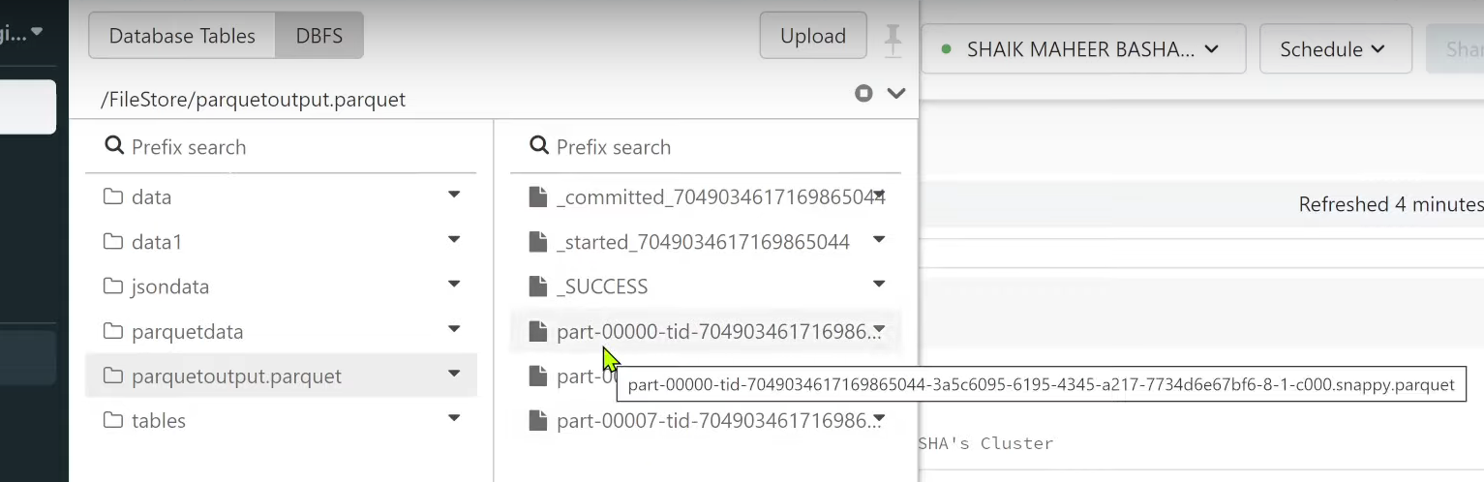

All the 3-part files are parquet files i.e., All of my data stored in 3 parquet files and folder is created as parquetoutput.parquet instead of file.

If we save file like **df.write.parquet(‘dbfs:/FileStore/parquetoutput’)** , parquet output folder will be created as shown below.

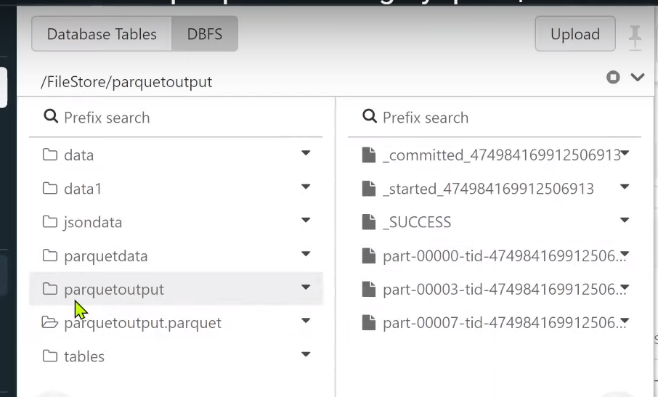

**df1 = spark.read.parquet(‘dbfs:/FileStore/parquetoutput’)**

**display(df1)**

**df.write.parquet(‘dbfs:/FileStore/parquetoutput’ , mode =’append’) 🡪 whatever data there in df it will again append the data in to the path mentioned in the syntax.**

**df1 = spark.read.parquet(‘dbfs:/FileStore/parquetoutput’)**

**display(df1)**

op:

|  |  |  |
| --- | --- | --- |
|  | Id | Name |
| 1 | 1 | sravs |
| 2 | 1 | sravs |
| 3 | 2 | anthi |
| 4 | 2 | anthi |

Now if I again overwrite ,

**df.write.parquet(‘dbfs:/FileStore/parquetoutput’ , mode =overwrite) 🡪 whatever data there in the file path that data will be overwritten i.e., data present in the location will be deleted and whatever new data we are adding that data will only be present.**

**df1 = spark.read.parquet(‘dbfs:/FileStore/parquetoutput’)**

|  |  |  |
| --- | --- | --- |
|  | Id | Name |
| 1 | 1 | sravs |
| 2 | 2 | anthi |

**SHOW FUNCTION:**

Show function by default shows only 20 characters in a given column. If column value is more than 20 characters, then it will truncate up to 20 characters only. Also show function by default shows up to maximum of 20 rows . If you have more than 20 rows, then we need to explicitly say how many rows we want actually.

**help(df.show)**

E.g.: **data = [(1,’abcdefghijhdffgjafjsdjk’) ,(2,’dgahdjuasdgfjkfkfajdjshkd’),(3,’asgfhdcbchndgdjsfdhahsjdkhskl’)]**

**schema =[‘id’,’comments’]**

**df=spark.createDataFrame(data,schema)**

**df.show()** 🡪 it will show column data with truncation of 20 characters only in comments column.

By default, columns data in below table truncates with only 20 characters.

|  |  |
| --- | --- |
| id | comments |
| 1 | abcdefghijhdffgja… |
| 2 | dgahdjuasdgfjkfkf… |
| 3 | asgfhdcbchndgdjsf… |

If I want to see entire column data even if it is more than 20 characters, we need to use below command.

**df.show(truncate=False)** 🡪 execute, below table will be shown

|  |  |
| --- | --- |
| id | comments |
| 1 | abcdefghijhdffgjafjsdjk |
| 2 | dgahdjuasdgfjkfkfajdjshkd |
| 3 | asgfhdcbchndgdjsfdhahsjdkhskl |

If I don’t want to show full column data , want to show only up to 8 characters , for that we use below command.

**df.show(truncate=8)** 🡪 execute, below table will be shown

|  |  |
| --- | --- |
| id | comments |
| 1 | abcde… |
| 2 | dgahd… |
| 3 | asgfh… |

If I want to show only 2 rows from data frame, we can use n=2 in command as shown below.

**df.show(n=2, truncate=False)** 🡪 execute, below table will be shown.

|  |  |
| --- | --- |
| id | comments |
| 1 | abcdefghijhdffgjafjsdjk |
| 2 | dgahdjuasdgfjkfkfajdjshkd |

Now if we see above table , columns (id and comments) are in horizontally, if we want to show columns in vertically , we will keep vertical =3.

**df.show(n=4,truncate= False, vertical = True)** 🡪 execute, below table will be shown in vertical format.

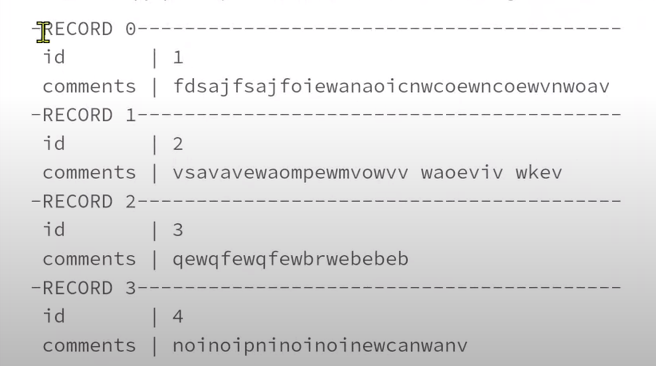

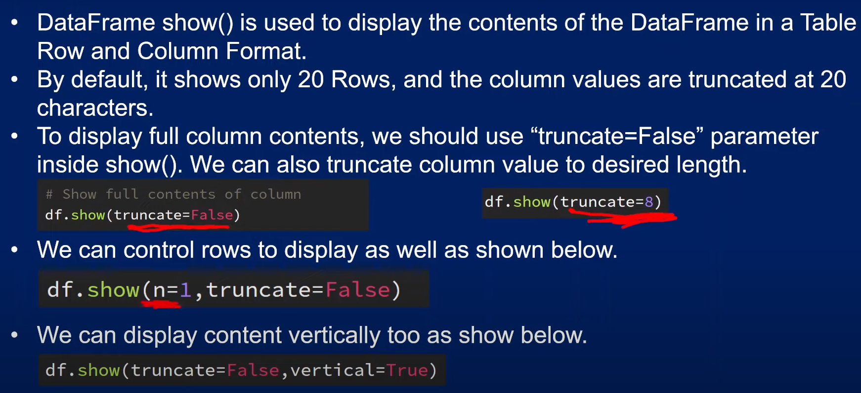

**withColumn() FUNCTION**

Once we load data into data frame, we may have a requirement of adding a new column to it or may be altering or changing the existing column value or existing column data types in data frame, in such scenarios we have to use withColumn() function. withColumn() function basically update the existing column it can be like column data type update/column value update, or it will add a new column all together.

If we are trying to transform data on top of data frame , it is called transformation function. Whenever we transform the data on top of data frame, actually we are not altering data frame, we create a new data frame out of it actually.

**data= [(1,’Sravs’,’5000’) ,(2,’anthi’,’6000’)]**

**columns=[‘id’,’name’,’salary’]**

**df=spark.createDataFrame(data,columns)**

**df.show()**

|  |  |  |
| --- | --- | --- |
| id | name | salary |
| 1 | sravs | 5000 |
| 2 | anthi | 6000 |

**df.printSchema()** 🡪 we will get schema of data frame.

Op: id: long (nullable= true)

name: string (nullable = true)

salary: string (nullable = true)

if we run printSchema function, how column data types are created means createDataFrame function will automatically infer the column data types based upon the values we supply. By default, if there is an integer , it will take it as long data type, if anything in single quote/double quote it will take it as a string type.

Now I want to convert salary column, which is in string type to integer type , for that we can use withColumn function.

**help(df.withColumn)**

**CHANGING COLUMN DATA TYPE USING withColumn FUNCTION:**

**from pyspark.sql.functions import col**

**df1 = df.withColumn(‘salary’ , col(‘salary’).cast(‘Integer’))** 🡪 using col here so we need to import col function and cast function used here to convert the data type.

**df1.show()**

|  |  |  |
| --- | --- | --- |
| id | name | salary |
| 1 | sravs | 5000 |
| 2 | anthi | 6000 |

**df1.printSchema()**

Op: id: long (nullable= true)

name: string (nullable = true)

salary: integer (nullable = true)

**UPDATING VALUES IN A COLUMN**

**from pyspark.sql.functions import col**

**df2=df1.withColumn(‘salary’ , col(‘salary’)*2)**

**df2.show()**

|  |  |  |
| --- | --- | --- |
| id | name | salary |
| 1 | sravs | 10000 |
| 2 | anthi | 12000 |

**ADDING NEW COLUMN IN A DATA FRAME**

When we are specifying new column name here to be added as a new column, it will check with same name ,is there any column already in the data frame . if yes , then changes will happen on that column itself or else it will create a new column altogether. Since there is no new column called country , it creates a new column altogether

**df3 = df2.withColumn(‘country’ , lit(‘india’))**

**df3.show()**

|  |  |  |  |
| --- | --- | --- | --- |
| id | name | salary | country |
| 1 | sravs | 10000 | india |
| 2 | anthi | 12000 | india |

**CREATE NEW COLUMN WITH SAME VALUES OF EXISTING COLUMNS**

**df4 = df3.withColumn(‘copiedSalary’ ,col(‘salary’))**

**df4.show()**

|  |  |  |  |  |
| --- | --- | --- | --- | --- |
| id | name | salary | country | copiedSalary |
| 1 | sravs | 10000 | india | 10000 |
| 2 | anthi | 12000 | india | 12000 |

**SUMMARY OF withColumn METHOD**

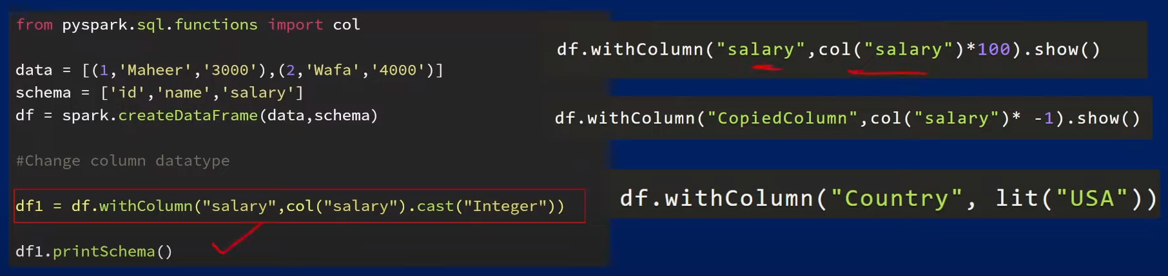

**withColumnRenamed() USAGE**

This function helps to rename/change existing column in data frame.

**data = [(1,’sravs’, ‘2000’),(2,’anthi’ , ‘3000’)]**

**cols=[‘id’ ,’name’, ‘salary’]**

**df = spark.createDataFrame(data,cols)**

**df.show()**

|  |  |  |
| --- | --- | --- |
| id | name | salary |
| 1 | sravs | 2000 |
| 2 | anthi | 3000 |

Data frames are actually immutable i.e., we cannot change the existing data frame . so always whatever the transformation function we apply, will generate another data frame from it and that data frame we can store it into some data frame variable.

Syntax: **df1 = df.withColumnRenamed(‘existing_column’ , ‘new_column’)**

**df1 = df.withColumnRenamed(‘salary’ , ‘salary_amount’)**

**df1.show()**

op:

|  |  |  |
| --- | --- | --- |
| id | name | salary_amount |
| 1 | sravs | 2000 |
| 2 | anthi | 3000 |

**STRUCTTYPE AND STRUCTFIELD IN PYSPARK:**

Structure type and structure field classes are used when we want to programmatically specify schema of to our data frame. When we are creating data frame, if we want to apply some schema/some structure to it, then we can use structure type and structure field classes. Structure type is nothing but collection of structure fields only.

**data = [(1, ‘sravs’, 3000),(2,’anthi’ ,4000)]**

**df=spark.createDataFrame(data)**

**df.show()**

|  |  |  |
| --- | --- | --- |
| _1 | _2 | _3 |
| 1 | sravs | 3000 |
| 2 | anthi | 4000 |

No column names were created in above table since schema is not created explicitly , so column names are like underscore 1, 2, 3.

**df.printSchema()** 🡪 how we are getting schemas means pyspark or data bricks system inferring the schema . Based on type of data here, it is taking long as a value for integers and characters as string.

_1: long (nullable = true)

_2: string (nullable = true)

_3: long (nullable = true)

Using Structure Type and Structure Field also we can define a schema to a data frame, and we can define in a very good manner, and we can create a complex columns as well like nested structure columns and all.

To use structure types in code, first we need to export from pyspark.sql.types import StructType, StructField. Importing StringType and IntegerType too because column data is values for few cols 🡪 IntegerType and characters for few columns so 🡪 StringType .

from pyspark.sql.types import StructType, StructField,StringType, IntegerType

**data = [(1,’sravs’,3000),(2,’anthi’,4000)]**

StructureType is nothing but collection of Structure Fields i.e., list of structure fields , we will use a list and in the list first item is going to be structure field , and to this Structure field we will pass column name and data type of column name.

**schema = StructType([\**

**StructField(‘id’, IntegerType()),\**

**StructField(‘name’, StringType()),\**

**StructField(‘salary’, IntegerType())**

**])** 🡪 we built schema for our data frame , we are creating our entire structure of the data frame. Entire structure is now in schema variable and that schema variable we will supply in createDataFrame function.

**df = spark.createDataFrame(data,schema)**

**df.show()**

|  |  |  |
| --- | --- | --- |
| id | name | salary |
| 1 | sravs | 3000 |
| 2 | anthi | 4000 |

**df.printSchema()**

op: id : integer (nullable = true)

name : string (nullable = true)

salary : integer (nullable = true)

**COMPLEX COLUMN’S STRUCTURE CREATION:**

We can create complex columns as well for e.g.: assume we have an address column, inside address column , there will be another sub column or nested column like street num, pin code like that . These kind of nested structure columns also we can create . we will call it as complex columns.

**from pyspark.sql.types import StructType, StructField , IntegerType,StringType**

**data =[(1,(‘sravs’ ,’anthi’), 3000),(2,(‘pala’,’dugu’),4000)]**

**structName = StructType([\**

**StructField(‘firstName’ , StringType()),\**

**StructField(‘lastName’ , StringType())**

**])**

**schema = StructType([\**

**StructField(‘id’,IntegerType()),\**

**StructField(‘name’,structName),\**

**StructField(‘salary’,IntegerType())**

**])**

**df= spark.createDataFrame(data,schema)**

**df.show()**

|  |  |  |
| --- | --- | --- |
| id | name | salary |
| 1 | {sravs,anthi} | 3000 |
| 2 | {pala,dugu} | 4000 |

If we use display function,

**display(df)**

|  |  |  |  |
| --- | --- | --- | --- |
|  | id | name | salary |
| 1 | 1 | {“firstName”: “sravs”, “lastName” : “anthi”} | 3000 |
| 2 | 2 | {“firstName”: “pala”, “lastName” : “dugu”} | 4000 |

If we expand name column,we can see data in a very detailed manner by the use of display function.

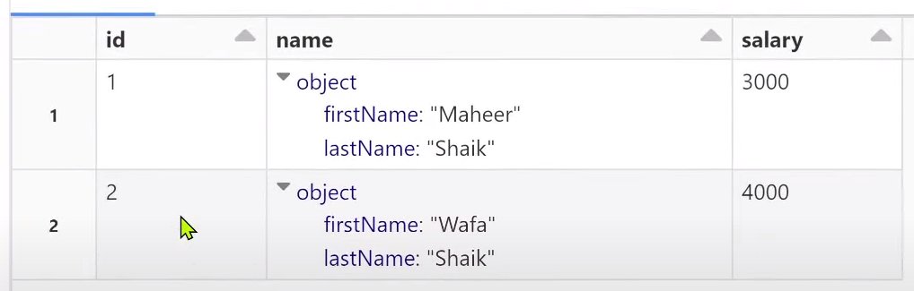

**df.printSchema()**

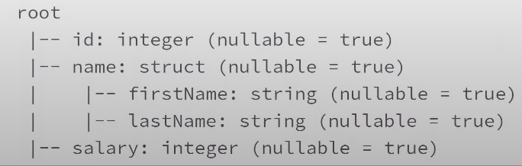

**ArrayType COLUMN IN PYSPARK:**

**data = [(‘abc’ ,[1,2]) , (‘mno’ ,[4,5]), (‘xyz’ ,[7,8])]**

**schema =[‘id’,’numbers’]**

**df = spark.createDataFrame(data,schema)**

**df.show()**

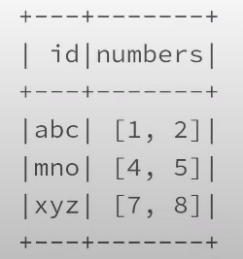

**df.printSchema() 🡪** we haven’t mentioned numbers column data type but how we are getting array type means createDataFrame function based on type of data we have passed, it will try to infer the schema, it will take schema data type automatically.

In below op , column id is a string type, numbers column is an array type whereas elements in number column are of long type. If we want integer type, we will explicitly specify like this 🡪 ArrayType(IntegerType()) via StructType syntax as shown below.

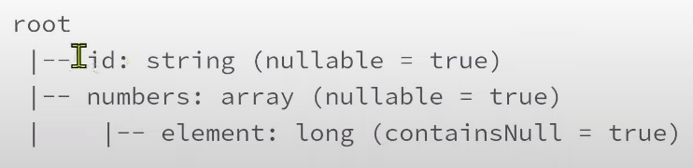

If we want to mention ArrayType explicitly, we will do it via StructType as shown below.

**from pyspark.sql.types import StructType,StructField,IntegerType,StringType,ArrayType**

**data = [(‘abc’ ,[1,2]) , (‘mno’ ,[4,5]), (‘xyz’ ,[7,8])]**

**schema = StructType([\**

**StructField(‘id’,StringType()),\**

**StructField(‘numbers’,ArrayType(IntegerType()))**

**])**

**df = spark.createDataFrame(data,schema)**

**df.show()**



**df.printSchema()** 🡪 now numbers column is array type with integer elements in an array instead of long type.

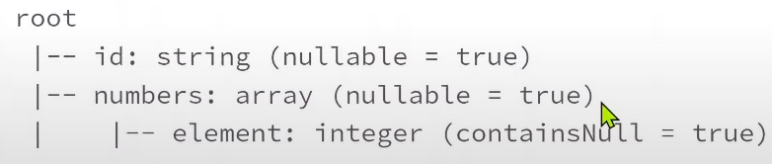

**display(df)**

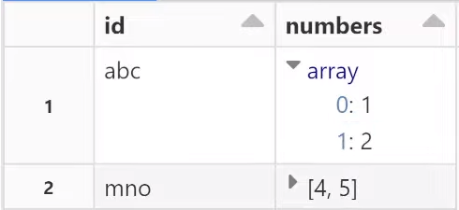

In ArrayType columns using indexes , we can access every element in an array .

**df.withColumn(‘firstNumber’, col(‘numbers’)[0]).show()** 🡪 we can access elements in array like this but for that we need to import col, or we can access elements in an array using below syntax too.

**df.withColumn(‘firstNumber’ , df.numbers[0]).show()**

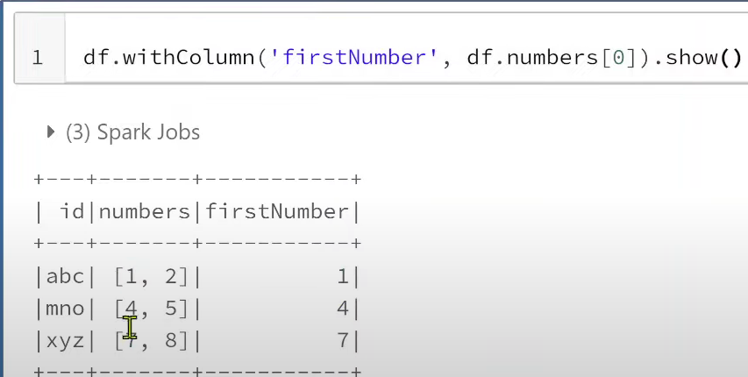

**COMBINE COLUMNS INTO AN ARRAY**

**E.g.: from pyspark.sql.functions import col,array**

**data = [(1,2) ,(3,4)]**

**schema = [num1,num2]**

**df= spark.createDataFrame(data,schema)**

**df.show()**

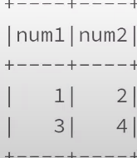

**df.withColumn(‘numbers’, array(col(‘num1’),col(‘num2’))).show() or**

**df.withColumn(‘numbers’ , array(df.num1,df.num2)).show()**

op:

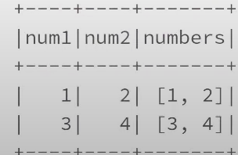

**df1 = df.withColumn(‘numbers’, array(col(‘num1’),col(‘num2’)))**

**df1.printSchema()**

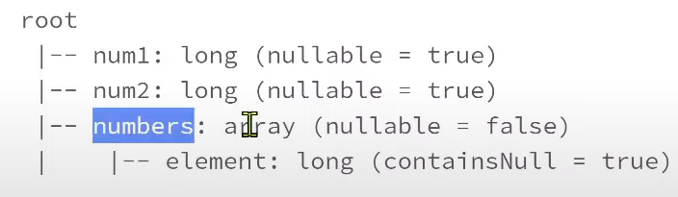

**Summary:** Array Type column will contain values like an array we can compare it like a list in python and each value will be having some index . we can access values using indexes.

**EXPLODE(), SPLIT() , ARRAY() , ARRAY_CONTAINS()**

explode(), split(), array(), array_contains() are widely used when we work with array type columns

**explode() FUNCTION USAGE:**

**data =[(1,’maheer’,[‘dotnet’,’azure’]),(2,’wafa’,[‘java’,’aws’])]**

**schema =[‘id’,’name’,’skills’]**

**df = spark.createDataFrame(data,schema)**

**display(df)**

**df.printSchema()**

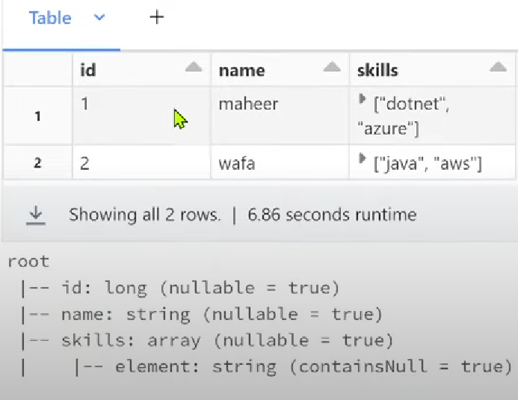

If we expand skills, we will get as below.

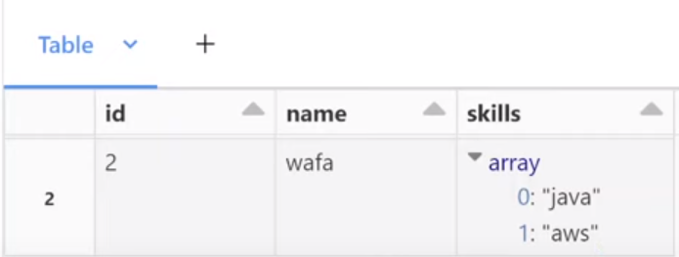

explode() function used to create a new row for each element in the given array column.

**from pyspark.sql.functions import explode,col**

**df.show()**

**df1=df.withColumn(‘skill’,explode(col(‘skills’)))**

**df1.show()**

The below screenshot shows before and after using explode function.

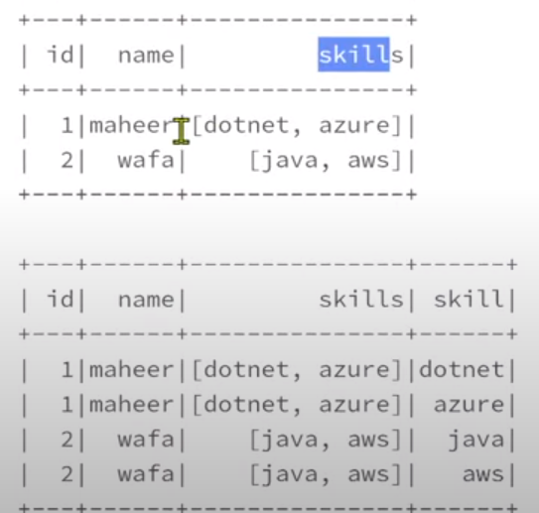

**split() FUNCTION USAGE:**

split() function used to split one string in to array type

**data =[(1,’maheer’,’dotnet,azure’),(2,’wafa’, ‘java,aws’)]**

**schema =[‘id’,’name’,’skills’]**

**df=spark.createDataFrame(data,schema)**

**display(df)**

**df.printSchema()**

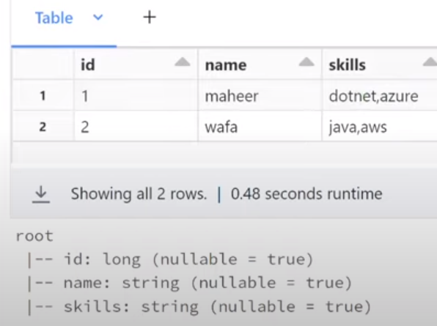

Using split() function, we will be splitting the string based on comma and the splitted values will become part of array and new column will be created which is array type.

**from pyspark.sql.functions import split,col**

**df.show()**

**df1 =df.withColumn(‘skillsArray’,split(col(‘skills’), ‘,’)) 🡪 based on , separator we will split string in to array.**

**df1.show()**

below screenshot shows before and after usage of split function.

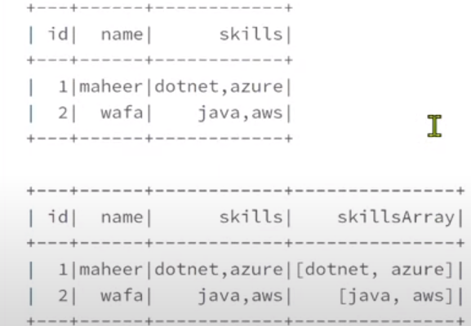

**Array() FUNCTION USAGE:**

array() function is used to create a new array column by merging data from multiple columns.

**from pyspark.sql.functions import col,array**

**data = [(1,’maheer’,’dotnet’,’azure’),(2,’wafa’,’java’,’aws’)]**

**schema = [‘id’,’name’,’primarySkill’,’secondarySkill’]**

**df = spark.createDataFrame(data,schema)**

**display(df)**

**df.printSchema()**

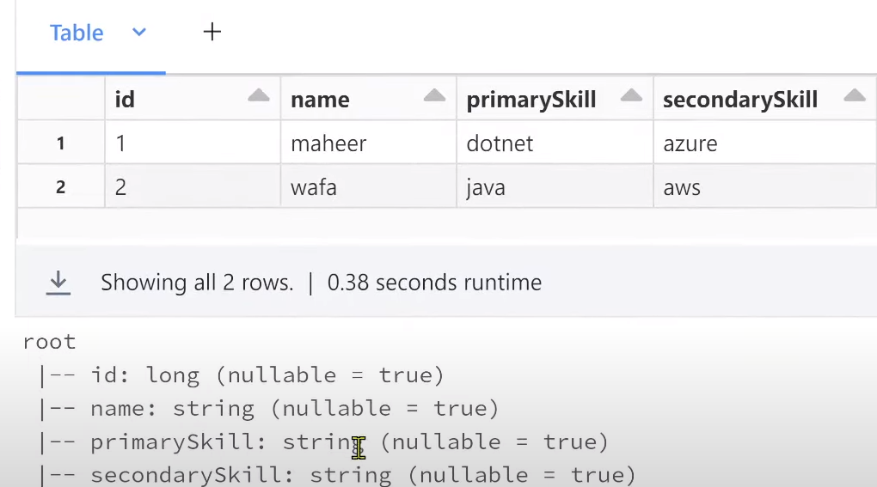

**df1= df.withColumn(‘skillsArray’ , array(col(‘primarySkill’),col(‘secondarySkill’)))**

**df1.show()**

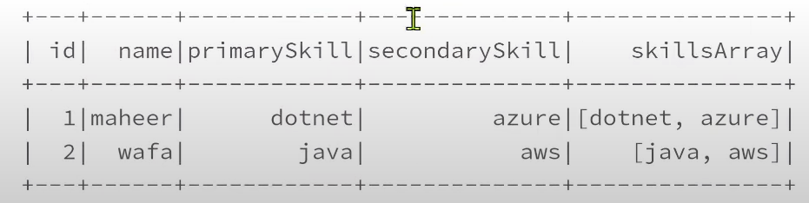

**array_contains() FUNCTION USAGE:**

array_contains() function useful to check given element is there or not in array. If given element is there in an array, it returns true. if it is not there , it returns false. returns null if array itself is null.

**data =[(1,’maheer’,[‘dotnet’,’azure’]),(2,’wafa’,[‘java’,’aws’])]**

**schema =[‘id’,’name’,’skills’]**

**df= spark.createData Frame(data,schema)**

**display(df)**

**df.printSchema()**

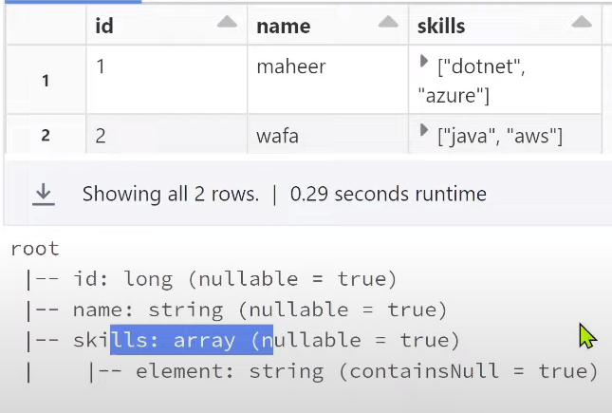

**from pyspark.sql.functions import array_contains, col**

**df1= df.withColumn(‘HasJavaSkill’, array_contains(col(‘skills’), ‘java’))**

**df1.show()**

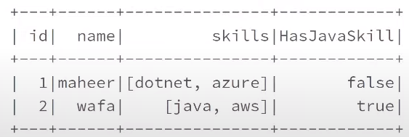

**MapType COLUMN USAGE IN PYSPARK:**

MapType column is used to represent map key-value pair similar to python dictionary

**data = [(‘maheer’,{‘hair’ : ‘black’ , ‘eye’ : ‘brown’}), (‘wafa’,{‘hair’ : ‘black’ ,’eye’: ‘blue’})]**

**schema =[‘name’,’properties’]**

**df= spark.createDataFrame(data,schema)**

**df.show()**

**df.printSchema()**

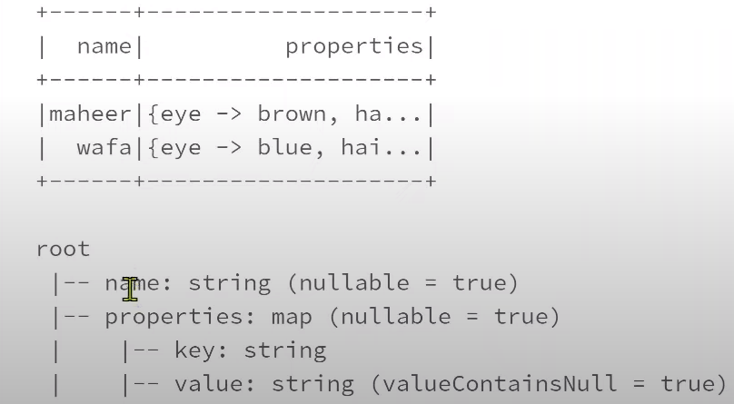

**df.show(truncate = False)**

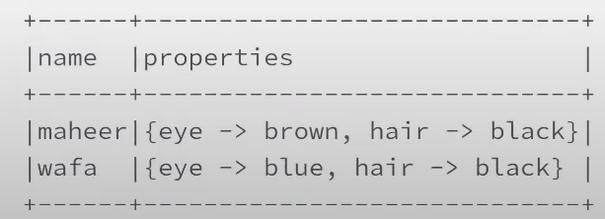

createDataFrame function will infer the schema automatically for properties column as map data type.

If we want to create data frame schema explicitly, we will do it via StructType as shown below.

**from pyspark.sql.types import StructType,StructField, StringType,MapType**

**data =[(‘maheer’,{‘hair’:’black’,’eye’:’black’}),(‘wafa’,{‘hair’:’black’,’eye’:’blue’})]**

**schema = StructType([\**

**StructField(‘name’,StringType()),\**

**StructField(‘properties’,MapType(StringType(),StringType()))**

**])**

**df=spark.createDataFrame(data,schema)**

**df.show(truncate=False)**

**df.printSchema()**

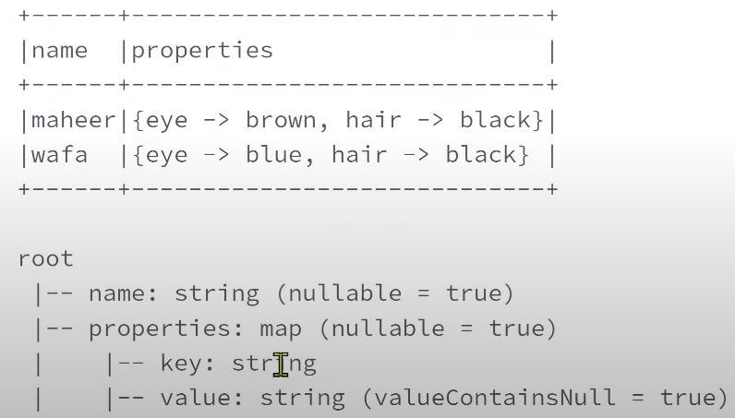

**HOW TO ACCESS MAPTYPE ELEMENTS:**

**display(df)**

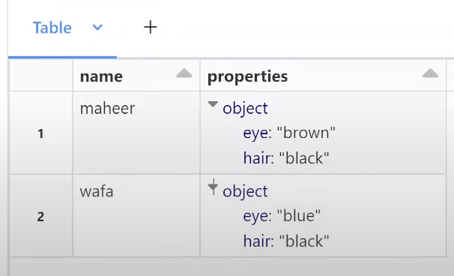

**df1= df.withColumn(‘hair’,df.properties[‘hair’])**

**df1.show(truncate=False)**

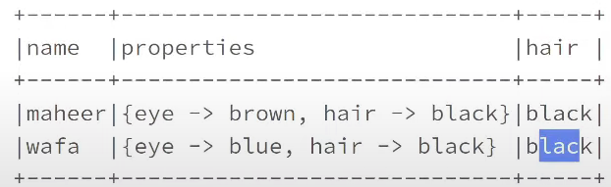

**df2= df1.withColumn(‘eye’, df.properties.getItem(‘eye’))**

**df2.show(truncate=False)**

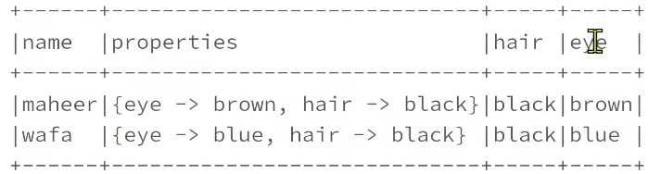

**We can use either of syntaxes to access map type elements df1= df.withColumn(‘hair’,df.properties[‘hair’]) or df2= df1.withColumn(‘eye’, df.properties.getItem(‘eye’))**

**HOW TO USE explode() FUNCTION FOR MAP TYPE COLUMNS :**

**from pyspark.sql.types import StructType,StructField, StringType,MapType**

**data =[(‘maheer’,{‘hair’:’black’,’eye’:’black’}),(‘wafa’,{‘hair’:’black’,’eye’:’blue’})]**

**schema = StructType([\**

**StructField(‘name’,StringType()),\**

**StructField(‘properties’,MapType(StringType(),StringType()))**

**])**

**df=spark.createDataFrame(data,schema)**

**df.show(truncate=False)**

**df.printSchema()**



The above code is same as MapType code. Now,

**from pyspark.sql.functions import explode**

**df1 = df.select(‘name’ ,’properties’, explode(df.properties )) 🡪 this explode function will give 2 more columns keys and values. Key column will hold all keys and value column will hold all values.**

**df1.show(truncate =False)**

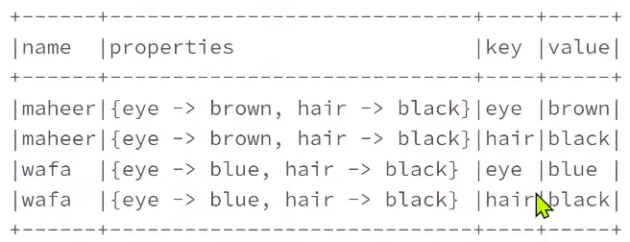

**map_keys() FUNCTION USAGE :**

map_keys() function used to extract keys from the map type column and keys column data will be in list format.

**from pyspark.sql.functions import map_keys**

**df1=df.withColumn(‘keys’, map_keys(df.properties))**

**df1.show(truncate = False)**

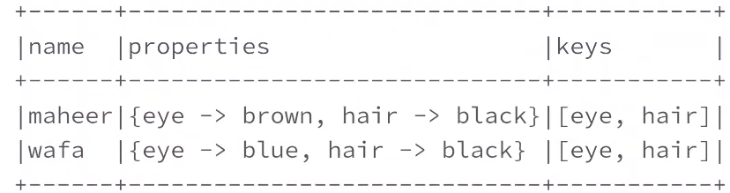

**map_values() FUNCTION USAGE :**

**from pyspark.sql.functions import map_values**

**df1=df.withColumn(‘values’, map_values(df.properties))**

**df1.show(truncate = False)**

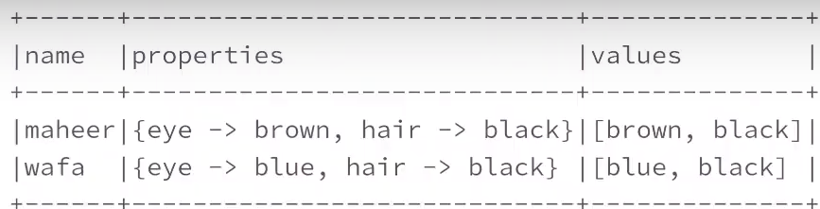

**map_keys() , map_values() , explode() functions are commonly used functions when we work in real time with map type columns**

**Row() class IN PYSPARK:**

Using Row() class , we can create objects for our rows in the data frame.

**from pyspark.sql import Row**

**row = Row(‘maheer’,2000)** 🡪 passed 2 values to Row class and entire code will create a row object which is of row type and that I am storing it into row object.

🡪 If I want to access maheer value , we will use index actually because row class is an extension of tuple. row is a tuple object and ‘maheer’ and 2000 are items inside a tuple , if we want to access items inside tuple , we need to use indexes

**print( row[0] + ‘ ‘ + str(row[1]))** 🡪 + used here for concatenation and ‘ ‘ for space . used str(row[1]) because row[0] value is string type and row[1] value is integer type so converting row[1] value to string type.

Op: maheer 2000

Now , we can also give names to each, and every item and that syntax shown below.

**row = Row(name = ‘maheer’,salary =2000)** 🡪 row object is created, and it has 2 properties . 1 is name property and 2 is salary property. Using name property we can access maheer , using salary property we can access 2000

**print(row.name + ‘ ‘ + str(row.salary))**

op: maheer 2000

Row() class used to create new rows in a data frame.

**from pyspark.sql import Row**

**row1 = Row(name=’maheer’,salary=2000)**

**row2 = Row(name=’wafa’, salary =3000)**

**data =[row1,row2]**

**df = spark.createDataFrame(data)**

**df.show()**

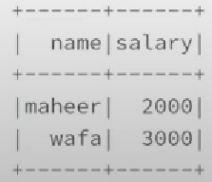

Using Row class , we can also create a class .

**Person=Row(‘name’,’age’)** 🡪 Using Row , we are supplying name and age into Row class, and we assign that into Person. Now Person will behave as a Person class.

**person1= Person(‘maheer’,30)** Now this Person will also act as a row class so for that row Person in the constructor , we are passing maheer and 2000 as values so maheer will set as a value for name property and 2000 will set as a value for age property.person1 is an object of Person class

**person2= Person(‘wafa’,5)**

Person is acting as a class similar to row class. Person class is created from Row class and ‘name’ and ‘age’ acts as a properties to it.

**print(person1.name) op: maheer**

**data =[person1,person2]**

**df= spark.createDataFrame(data)**

**df.show()**

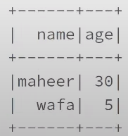

Using Row class, we can create a similar row like classes and that classes will get property names from the row class constructor, and we can use it accordingly

Using Row class, we can create a nested structure type columns as well as shown below.

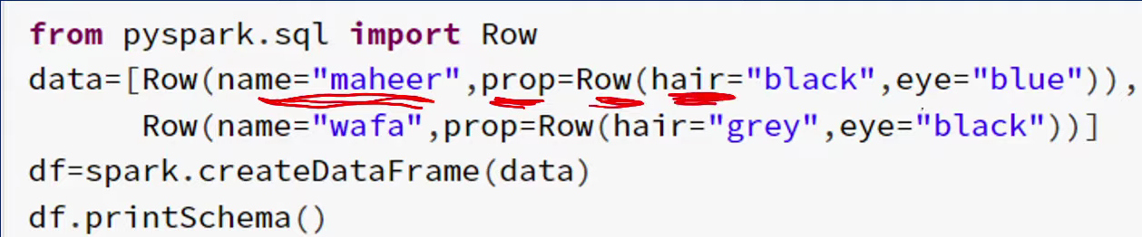

**data = [Row(name=’maheer’ ,prop =Row(age=30,gender=’male’)),\**

**Row(name=’wafa’, prop=Row(age=4,gender=’male’))]**

**df= spark.createDataFrame(data)**

**df.show()**

**df.printSchema()**

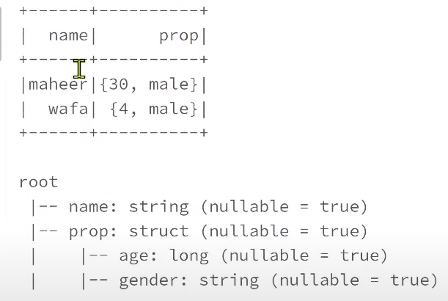

Row class is simply representation of every row in a data frame. It’s a row object that will come as a complete row data.

**Column class IN PYSPARK USAGE:**

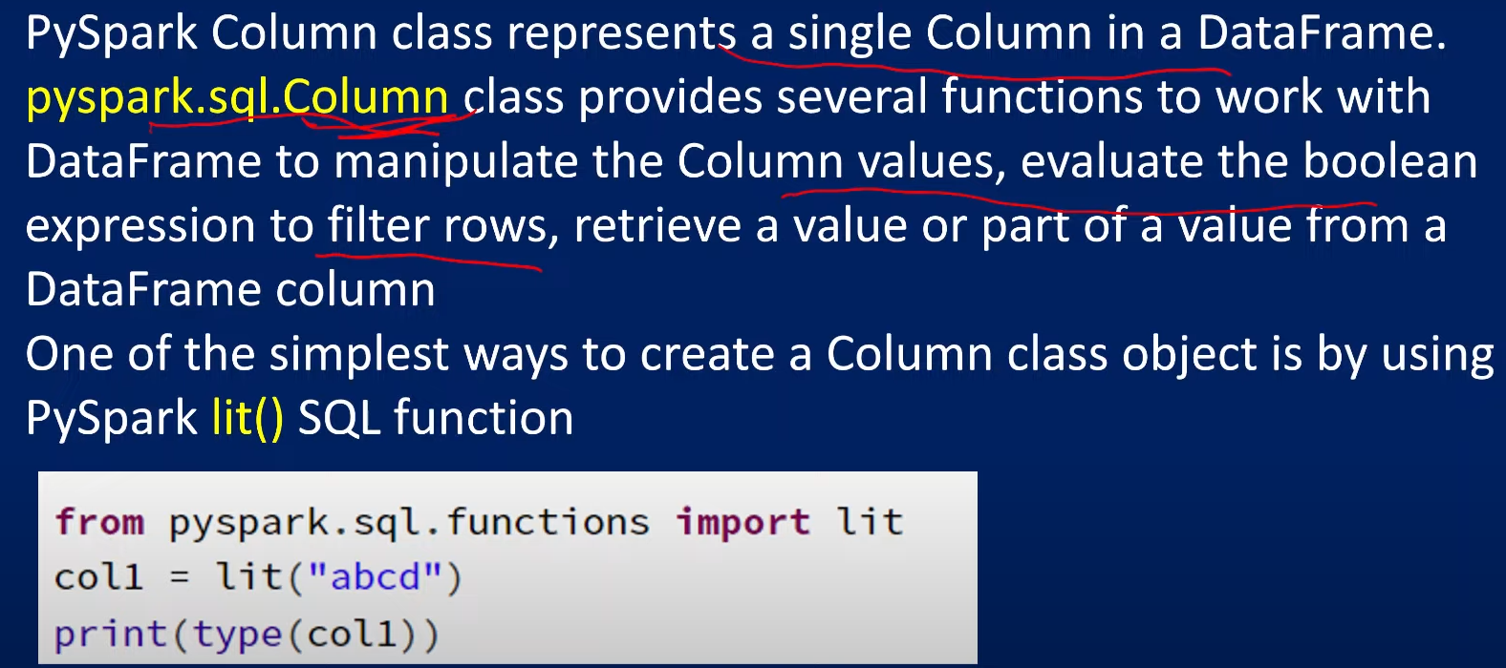

lit function will create new column in a data frame.

**from pyspark.sql.functions import lit**

**col1 = lit(‘abcd’)** 🡪 static literal values will take to col1 variables

**print(type(col1))** 🡪 col1 variable type is column

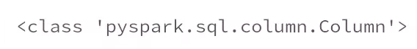

Eg2:

**from pyspark.sql.functions import lit**

**data =[(‘maheer’,’male’,2000),(‘wafa’,’male’,4000)]**

**schema =[‘name’,’gender’,’salary’]**

**df= spark.createDataFrame(data,schema)**

**df.show()**

**df.printSchema()**

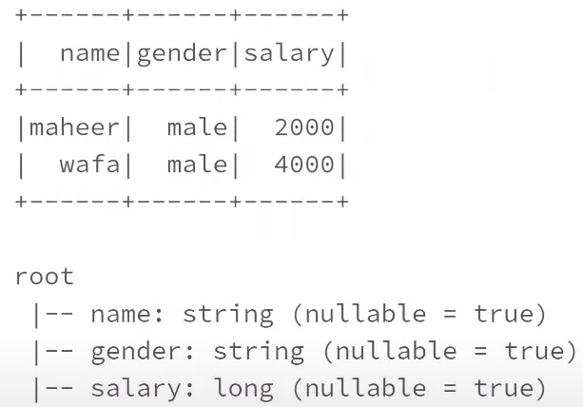

Now we will create lit function on top of df as shown below.

**df1 = df.withColumn(‘newCol’,lit(‘newColVal’))**

**df1.show()**

**df1.printSchema()**

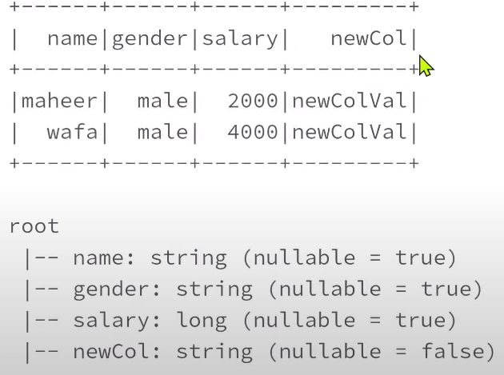

**VARIOUS WAYS TO ACCESS COLUMN FROM DATA FRAME**

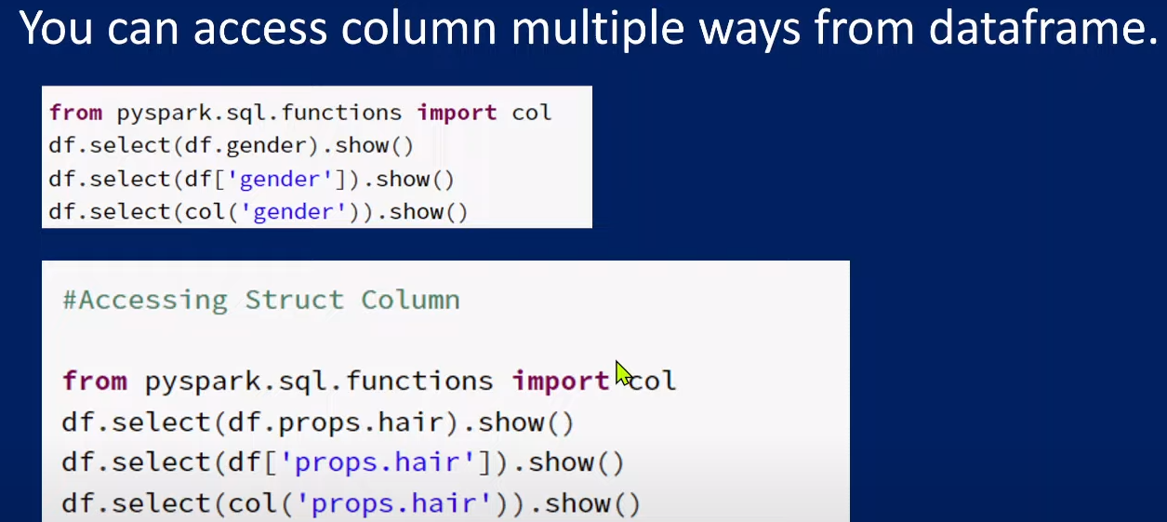

**df1.select(df1.name).show()**

**or**

**df1.select(df1[‘name’]).show()**

**or**

**from pyspark.sql.functions import col**

**df1.select(col(‘name’)).show()**

we can also access Structure type columns.

**from pyspark.sql.functions import lit**

**from pyspark.sql.types import StringType,StructType,StructField,IntegerType**

**data =[(‘maheer’,’male’,2000,(‘black’,’brown’)),(‘wafa’,’male’,4000,(‘black’,’blue’))]**

**propsType = StructType([\**

**StructField(‘hair’,StringType()),\**

**StructField(‘eye’,StringType())**

**])**

**schema = StructType([**

**StructField(‘name’,StringType()),\**

**StructField(‘gender’,StringType()),\**

**StructField(‘salary’,IntegerType()),\**

**StructField(‘props’, propsType)**

**])**

**df = spark.createDataFrame(data,schema)**

**df.show()**

**df.printSchema()**

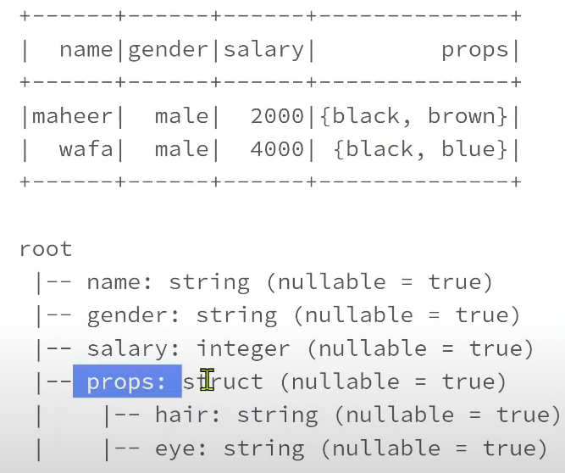

**df.select(df.props.eye).show() or**

**df.select(df[‘props.eye’]).show() or**

**from pyspark.sql.functions import col**

**df.select(col(‘props.eye’)).show()**

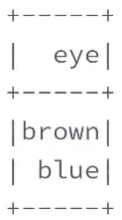

**when() & otherwise() FUNCTIONS IN PYSPARK:**

when() and otherwise functions are similar to SQL case statements . If we want to validate with some condition ,if condition is true , we want to get some data . if condition is false, we want to get some different data. In such scenarios we will use when() and otherwise() function.

Eg:

**data =[(1,’maheer’,’M’,2000),(2,’Asi’,’F’,3000),(3,’abcd’,’’,2000)]**

**schema =[‘id’,’name’,’gender’,’salary’]**

**df= spark.createDataFrame(data,schema)**

**df.show()**

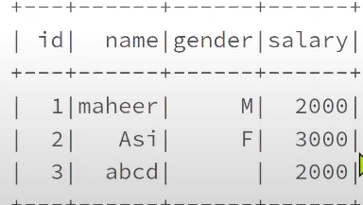

Now if we want to transform gender column values as male, and female based on values available in gender column. If column value is M we will update as male, if column value is F, we will update as Female, if column value is null, we will update it as unknown.

**from pyspark.sql.functions import when**

**help(when)**

**df1=df.select(df.id,df.name,when(df.gender==’M’,’male’).when(df.gender==’F’,’female’).otherwise(‘unknown))**

**df1.show()**

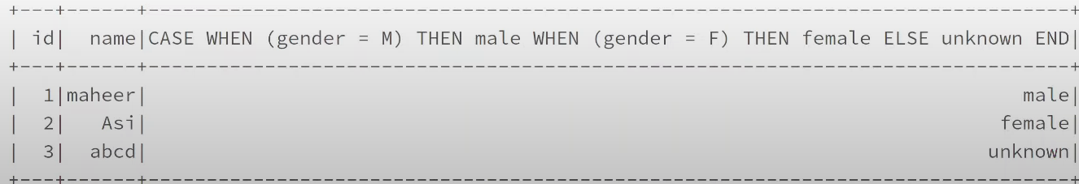

df1=df.select(df.id,df.name,**when(df.gender==’M’,’male’).when(df.gender==’F’,’female’).otherwise(‘unknown)**.**alias(‘gender’)**)

**df1.show()**

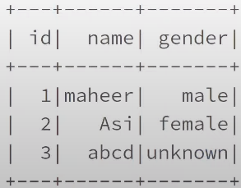

We can also split code with \ as shown below.

**df1=df.select(df.id,\**

**df.name,\**

**when(df.gender==’M’,’male’)\**

**.when(df.gender==’F’,’female’)\**

**.otherwise(‘unknown)\**

**.alias(‘gender’)\**

**)**

**alias() FUNCTION USAGE IN PYSPARK:**

**data =[(1,’maheer’,2000),(2,’wafa’,4000),(3,’asi’,3000)]**

**schema =[‘id’,’name’,’salary’]**

**df= spark.createDataFrame(data,schema)**

**df.show()**

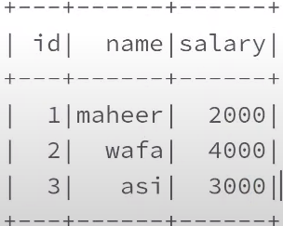

I want to get columns name differently, so in that case we will use alias function.

**df.select(df.id.alias(‘emp_id’),df.name.alias(‘emp_name’),df.salary.alias(‘emp_salary’)).show()**

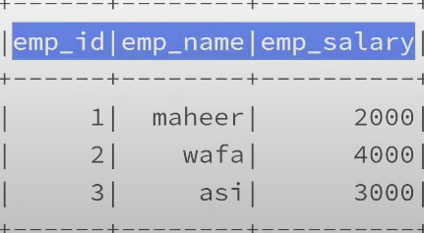

**asc() & desc() FUNCTION USAGE IN PYSPARK:**

asc() and desc() functions are used to sort columns in ascending and descending order.

**data =[(1,’maheer’,2000),(2,’wafa’,4000),(3,’asi’,3000)]**

**schema =[‘id’,’name’,’salary’]**

**df= spark.createDataFrame(data,schema)**

**df.sort(df.name.asc()).show()**

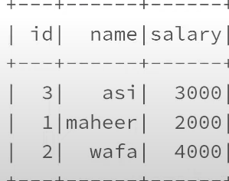

asc() and desc() functions used to order data .

**cast() FUNCTION USAGE IN PYSPARK:**

cast() function used to convert data type of any column.

**data =[(1,’maheer’,2000),(2,’wafa’,4000),(3,’asi’,3000)]**

**schema =[‘id’,’name’,’salary’]**

**df= spark.createDataFrame(data,schema)**

**df.printSchema()**

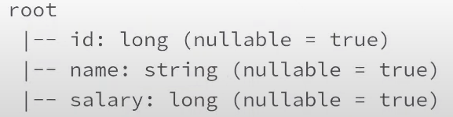

When we are creating data frame using createDataFrame function, if we don’t explicitly specify structure types for our schema along with the data types then based on the data what we pass, it will infer the schema automatically.

If I want to convert data type of salary to integer , then by use of cast function we will convert it.

**df1= df.select(df.id,df.name,df.salary.cast(‘int’))**

**df1.printSchema()**

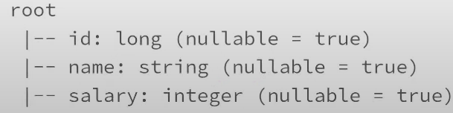

**like() FUNCTION USAGE IN PYSPARK:**

If we want to filter data from a data frame rows where name starts with M%, % indicates anything

**data =[(1,’maheer’,2000),(2,’wafa’,4000),(3,’asi’,3000),(4,’mahesh’,3000)]**

**schema =[‘id’,’name’,’salary’]**

**df= spark.createDataFrame(data,schema)**

**df.show()**

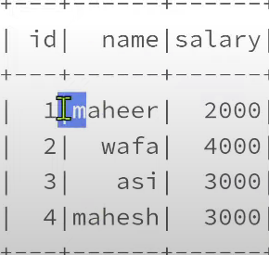

**df.filter(df.name.like(‘m%’)).show()**

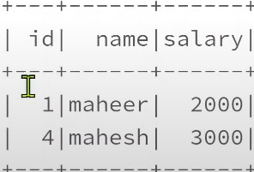

**filter() & where() FUNCTION USAGE IN PYSPARK:**

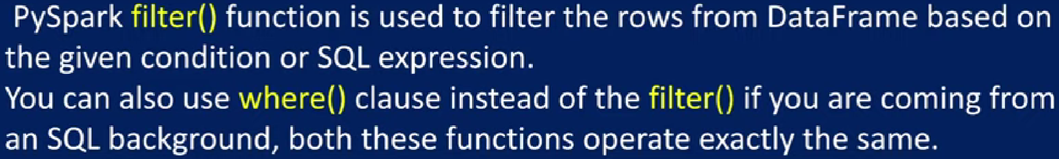

**data =[(1,’maheer’,’male’,2000),(2,’wafa’,’male’,3000),(3,’asi’,’female’,4000)]**

**schema =[‘id’,’name’,’gender’,’salary’]**

**df= spark.createDataFrame(data,schema)**

**df.show()**

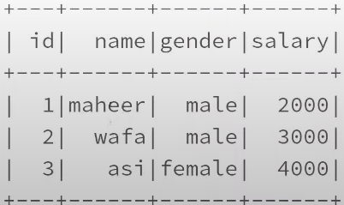

**help(df.filter)**

**df.filter(df.gender==’male’).show() or df.filter(“gender==’male’ “).show()**

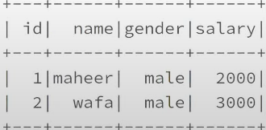

**df.where(df.gender==’male’).show() or df.where(“gender==’male’ “).show()**

**If we want to specify multiple conditions , then we will mention as below.**

**df.where((df.gender==’male’) & (df.salary==2000)).show()**

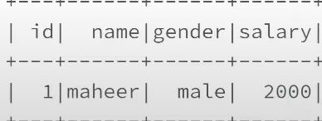

**distinct() & dropDuplicates() USAGE IN PYSPARK:**

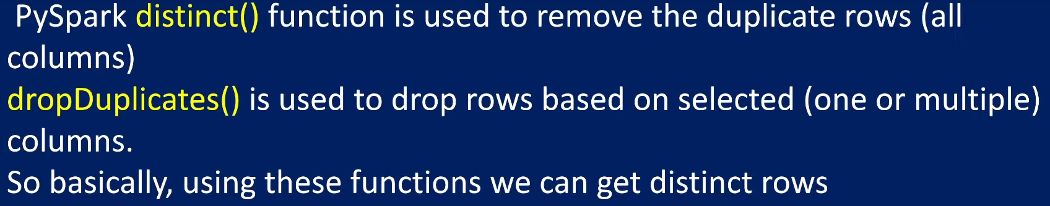

Distinct function will work on all columns i.e; it will take all columns into consideration and perform the distinct operation to get distinct rows. Where as dropDuplicates also will take all columns if we don’t specify any column or we can supply list of columns on which we want to perform this distinct operation

**Eg:**

**data = [(1,’maheer’,’male’,2000),(2,’wafa’,’male’,3000),(2,’wafa’,’male’,3000),(3,’asi’,’female’,3500)]**

**schema = [‘id’ , ‘name’, ‘gender’,’salary’]**

**df = spark.createDataFrame(data,schema) 🡪 spark key word used to create spark session object and this entire code will create a data frame and store this data frame into variable called df.**

**df.show()**

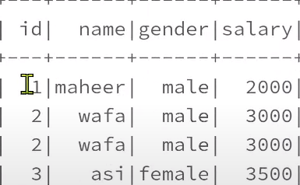

**help(df.distinct)**

**df.distinct.show()**

op:

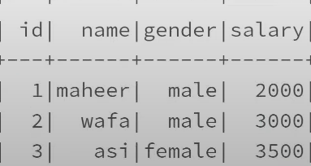

**df.dropDuplicates().show()** 🡪 removing duplicate rows based on all columns

op:



dropDuplicates() function also provides same result as distinct function. The only difference between dropDuplicates() and distinct function is : in dropDuplicates() function we can pass list of our column names . on a given column if I want to see distinct values from only gender column 🡪 we can’t use distinct function here because distinct() function applied on all columns. dropDuplicates() function will be applied on all columns if we don’t specify column list.

**help(df.dropDuplicates)**

Eg:

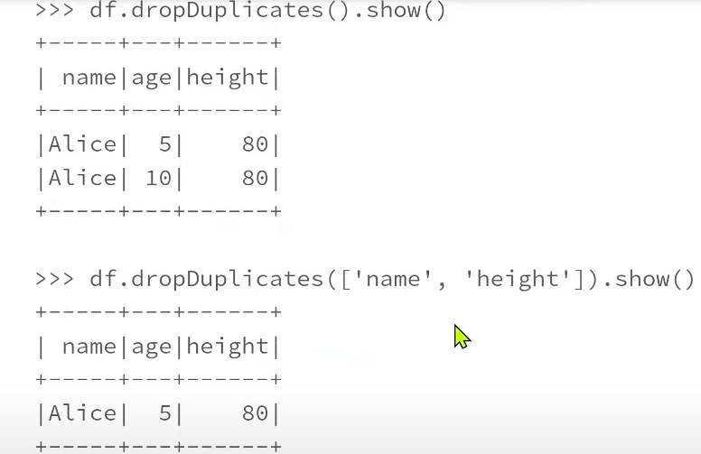

**df.dropDuplicates([‘gender’]).show()**

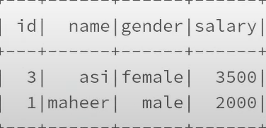

**orderBy() and sort() FUNCTIONS IN PYSPARK:**

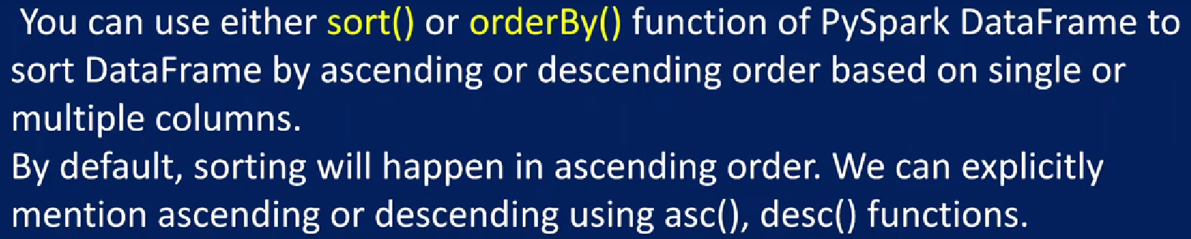

Eg:



**df.show()**

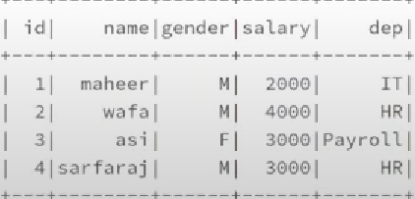

If we want to sort data by dep column, we will use sort function directly

help(df.sort)

df.sort(df.dep).show() 🡪 sorted by default in ascending order.

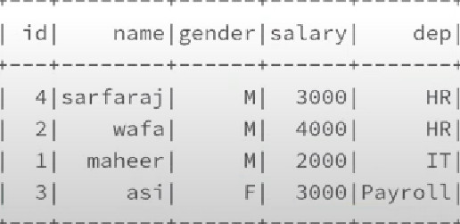

df.orderBy(df.dep).show()

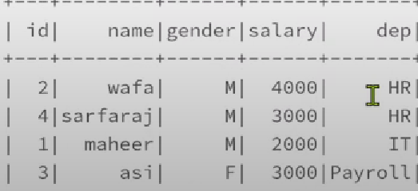

If we observe orderBy result and sort result , in sort function op, data is sorted in dep column. After sorting in dep column, then for every dep column , if want to sort via id column, we will add id column also in sort as shown below.

df.sort(df.dep,df.id).show()



df.sort(df.dep,df.id.desc()).show() 🡪 first we will sort dep in asc order and after getting result of dep in asc order we will sort id column in desc order.



df.sort(df.dep.desc(),df.id.desc()).show()

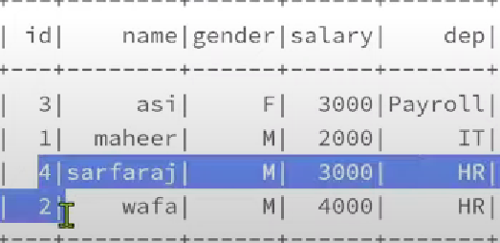

df.orderBy(df.dep.asc(),df.id.asc()).show() 🡪 Both orderBy and sort returns same result.

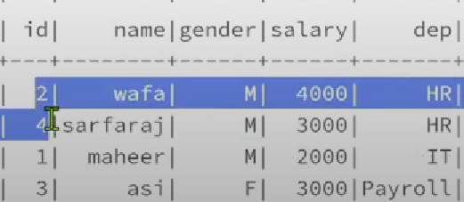

**union() & unionAll() METHOD IN PYSPARK:**

In SQL ,union() and unionAll() transformations are used to merge two or more dataframes of the same schema /structure. unionAll() method merges two data frames and returns new data frames withall rows. Where as union() method merges 2 data frames and returns new data frame with all rows by removing duplicate data.

Where as in pyspark, union() and unionAll() used to merge rows from two different data frames but removing duplicate part will not be done in pyspark. To remove duplicates we will use distinct() function.

In pyspark, union() and unionAll() both functions will do same thing .will return all the rows from both data frames . they don’t delete the duplicate rows . if we want to remove duplicate rows , we will use distinct function.

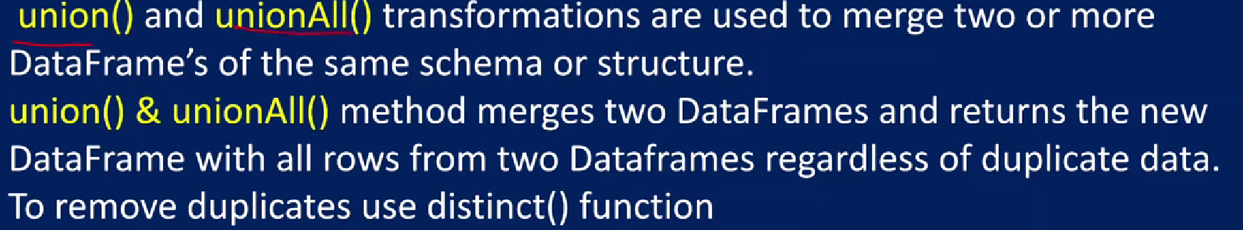

data1 = [(1,’maheer’,’male’),(2,’wafa’,’male’)]

schema1=[‘id’,’name’,’gender’]

data2 = [(3,’asi’,’female’),(4,’ayesha’,’female’)]

schema2=[‘id’,’name’,’gender’]

df1 =spark.createDataFrame(data1,schema1)

df2 =spark.createDataFrame(data2,schema2)

df1.show()

df2.show()

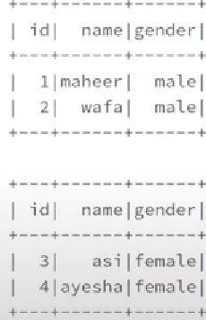

Both data frames has same schema , now we need to merge 2 data frames in to single data frame.

newDf = df1.union(df2)

newDf.show()

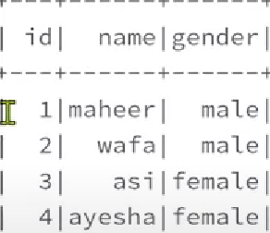

Eg:2 data1 = [(1,’maheer’,’male’),(2,’wafa’,’male’)]

schema1=[‘id’,’name’,’gender’]

data2 = [(1,’maheer’,’male’),(3,’asi’,’female’),(4,’ayesha’,’female’)]

schema2=[‘id’,’name’,’gender’]

df1 =spark.createDataFrame(data1,schema1)

df2 =spark.createDataFrame(data2,schema2)

df1.show()

df2.show()

newDf = df1.union(df2)

newDf.show()

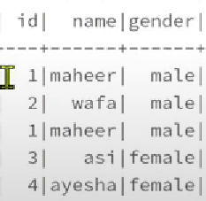

newDf= df1.unionAll(df2)

newDf.show()



In order to remove duplicates from above table, we need to use distinct function.

newDf.distinct().show()

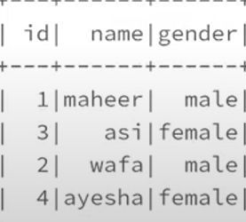

**groupBy() FUNCTION IN PYSPARK:**

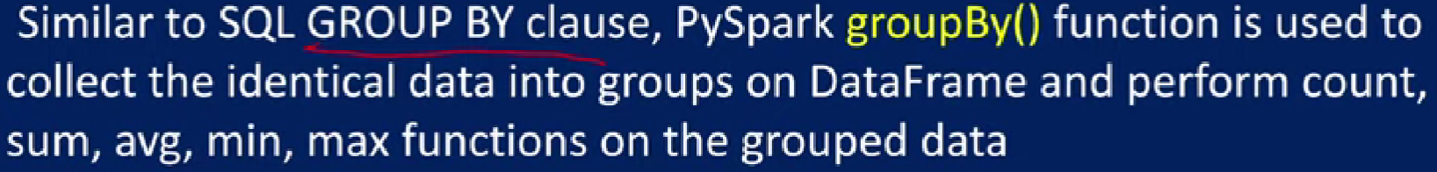

Eg: 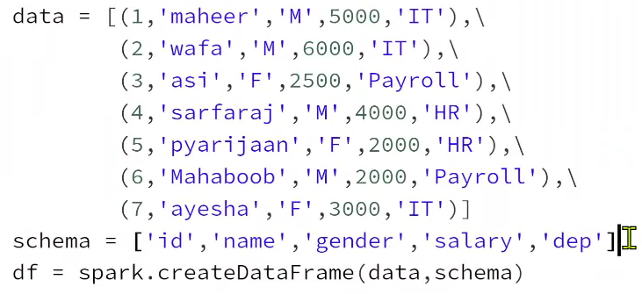df.show()

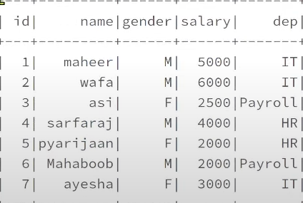

print((type(df.groupBy(df.dep))) op: Grouped Data Type

df1 = df.groupBy(df.dep).count()

df1.show()

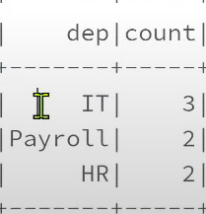

df1 = df.groupBy(df.dep).min(df.salary) or df1 = df.groupBy(‘dep’).min(‘salary’)

df1.show()

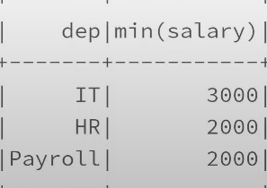

df1 = df.groupBy(‘dep’).max(‘salary’)

df1.show()

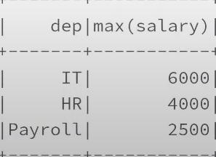

If we want to group with multiple columns, for each dep, for each gender , how many records we have.we can do it.

df1 = df.groupBy(‘dep’,’gender’).count()

df1.show()

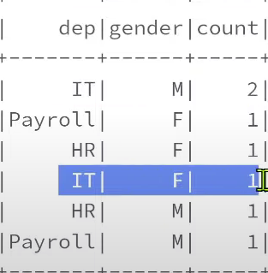

**Groupby agg() FUNCTION IN PYSPARK:**



Eg:

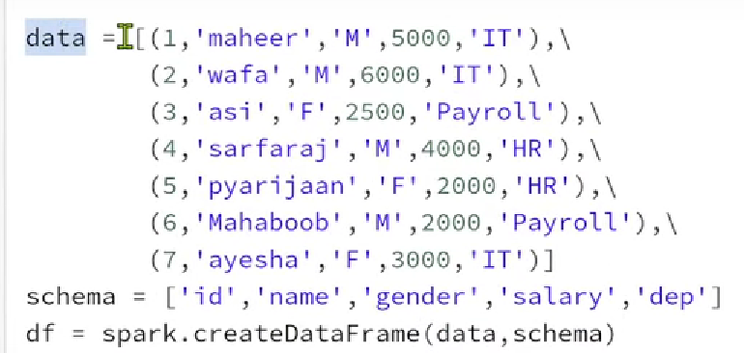

df.show()



df.groupBy(‘dep’).min().show()

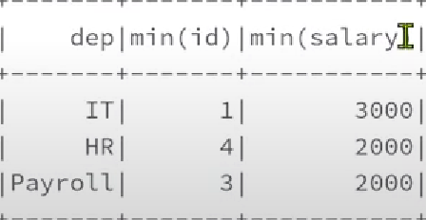

df.groupBy(‘dep’).min(‘salary’).show()

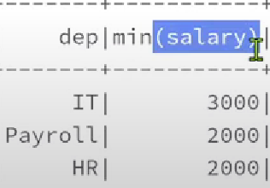

If I want to apply count() , min(), max() function at a single data frame at a single grouped data object , we need to use agg() function

from pyspark.sql.functions import count,min,max

df.groupBy(‘dep’).agg(count(‘*’).alias(‘countofEmps’)).show()

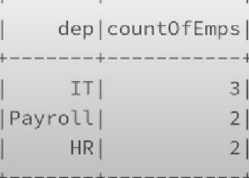

df.groupBy(‘dep’).agg(count(‘*’).alias(‘countofEmps’),\

min(‘salary’).alias(‘minSal’),\

max(‘salary’).alias(‘maxSal’)).show()

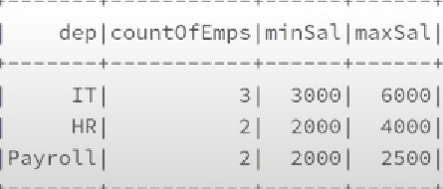

**unionByName() FUNCTION IN PYSPARK:**

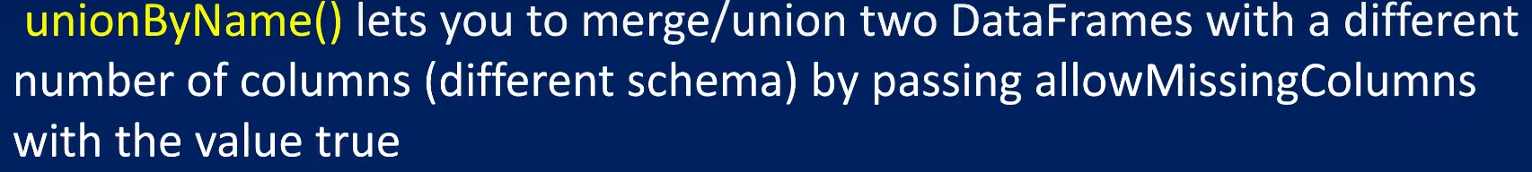

union() function will merge two data frames where the schema is similar. Union will merge the schema based on the column index i.e; column position whereas unionByName() actually match the schemas based on the column names . so with this feature we can merge two data frames even though there is a different schema but for that we need to pass this allowMissingColumns parameter to True so that whatever columns it misses there it will replaces it with a null.

Eg: data1= [(1,’maheer’,31]

schema1 =[‘id’,’name’,’age’]

data2= [(1,’maheer’,20]

schema2 =[‘id’,’name’,’salary’]

df1 = spark.createDataFrame(data1,schema1)

df2 = spark.createDataFrame(data2,schema2)

df1.show()

df2.show()

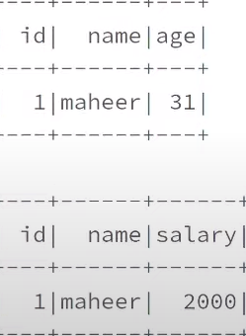

If we use union function it will still work even there are different schemas/columns , because union function will merge the rows based upon index . 0th index to 0th index, 1st index to 1st index , then 2nd index to 2nd index.

df1.union(df2).show()

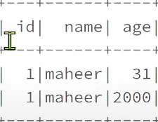

It merged 2 rows, but it taken column names only from first data frame because column positions and number of positions everything is same here. When it comes to unionByName() it will merge with the column names since column names didn’t match it will actually throw error so allow missing columns =True we are mentioning.

df1.unionByName(df2).show()

op: 

i.e; we have a column called age in df1 which is not available in df2. So not able to merge the rows. Even if we have different schema we want to perform merge means we will pass allowMissingColumns =True.

df1.unionByName(df2,allowMissingColumns=True).show()

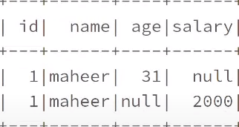

**select() FUNCTION IN PYSPARK:**



data =[(1,’maheer’,’male’,2000)]

schema = [‘id’,’name’,’gender’,’salary’]

df = spark.createDataFrame(data,schema)

df.show()

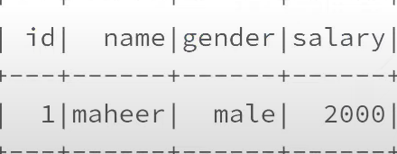

df.select(‘id’ ,’name’).show() or

df.select(df.id,df.name).show() or

df.select(df[‘id’],df[‘name’]).show() or

from pyspark.sql.functions import col

df.select(col(‘id’) ,col(‘name’)).show() 🡪 we can access data frame column data using select in 4 ways.

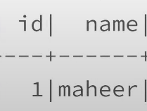

We can also pass column names as a list here.

df.select([‘id’,’name’]).show()



We can select all columns using below code.

df.select(‘*’).show() 🡪 we are passing * as a string so that it will select all columns from a data frame

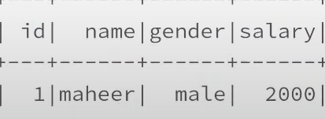

We can also use select function dynamically from list to select all columns.

df.select([col for col in df.columns]).show() 🡪 here in for loop df.columns will give us all column names. We are looping all column names and taking every item in to col and that item we are pasting it in to [col variable. So like that entire list will build with all column names & it will select all the columns

 we are creating list dynamically by looping through all the columns and list we are passing in to select function so it will automatically print column names for us .

**join() FUNCTION IN PYSPARK:**



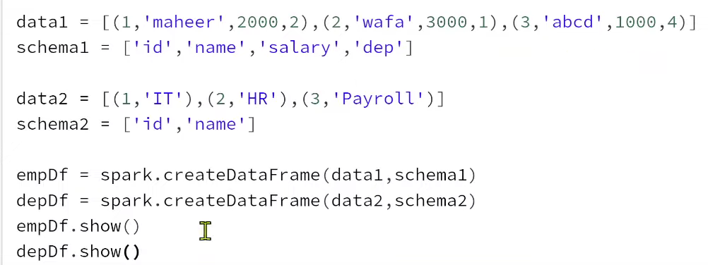

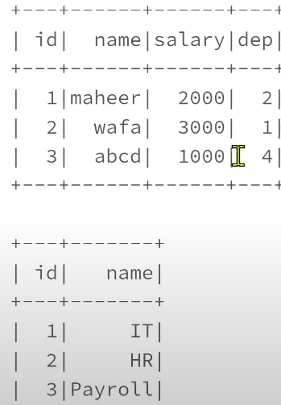

empDf.join(depDf,empDf.dep==depDf.id, ‘inner’).show()

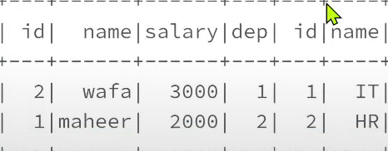

empDf.join(depDf,empDf.dep==depDf.id, ‘left’).show() 🡪 here empDf is left data frame and depDf is right data frame.

left join : from both data frames all the matching will come i.e; similar to inner join and it will give us missing information from the left table or left data frame.

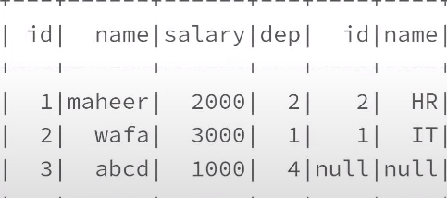

empDf.join(depDf,empDf.dep==depDf.id, ‘right’).show()

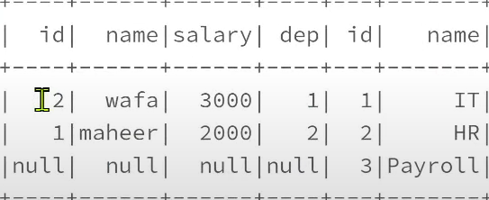

empDf.join(depDf,empDf.dep==depDf.id, ‘full’).show()

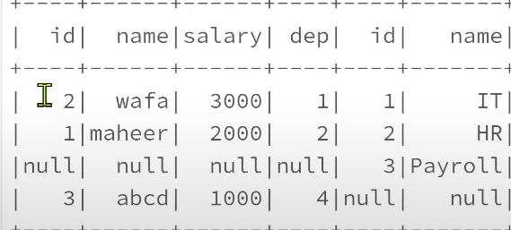

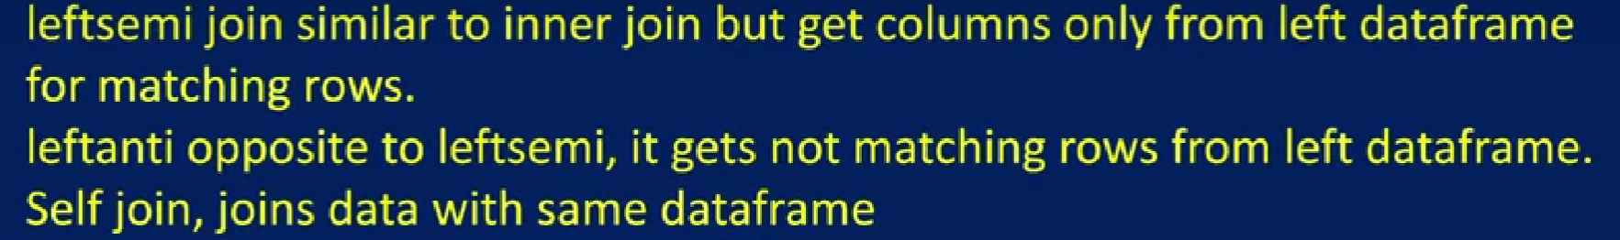

Eg:

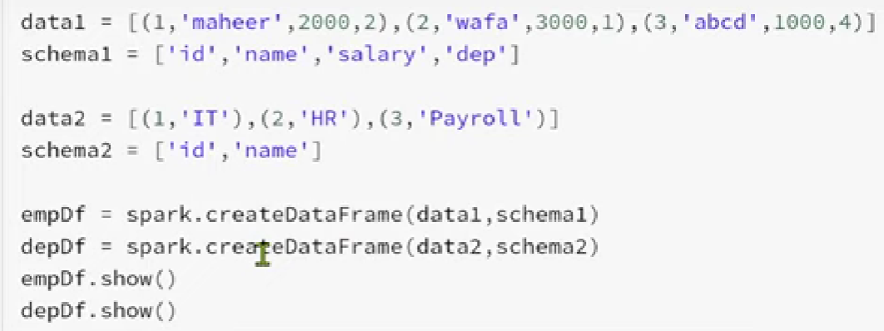

Op:

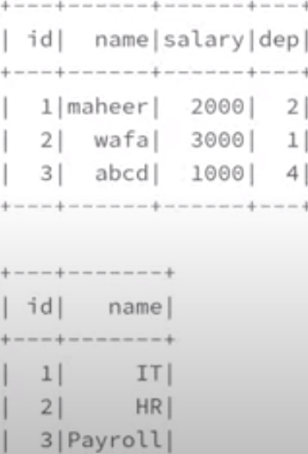

empDf.join(depDf,empDf.dep ==depDf.id,’inner’).show()

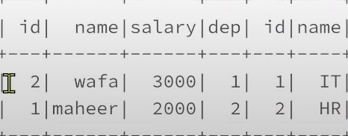

If we use left semi it will do same as inner join, but it will get columns only from the left table

empDf.join(depDf,empDf.dep ==depDf.id,’leftsemi’).show()

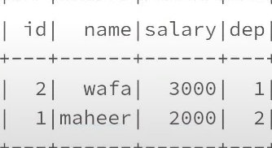 we got matching rows from left data frame.

leftanti is opposite to leftsemi, it will also get columns from the left data frame but it will get rows like nonmatching rows from left data frame.

empDf.join(depDf,empDf.dep ==depDf.id,’leftanti’).show()

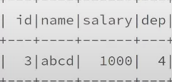

Self join: our data frame joining with same dataframe.

data1= [(1,’maheer’,0),(2,’wafa’,1),(3,’asi’,2)]

schema1= [‘id’ ,’name’,’managerId’]

df=spark.createDataFrame(data1,schema1)

df.show()

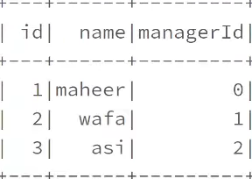

Let’s assume we have 3 employees here maheer, wafa and asi . wafa has a manager id of 1 i.e; maheer is a manager of wafa . asi has a manager id of 2 ,i.e; wafa is manager of asi. When it comes to maheer there is no manager id, manager id is 0 like top manager. Now I want to get all employee names and manager names side by side in a single table or single data frame. In this scenario , I want to perform self join(join with same data).

from pyspark.sql.functions import col

df.alias(‘empData’).join(df.alias(‘mgrData’),\

col(‘empData.managerId’)==col(‘mgrData.id’) \

,’inner’).show()

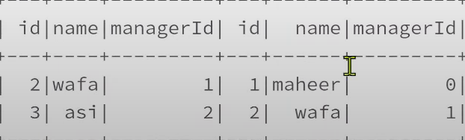

Wafa has managerId 1, asi has managerId 2 so it matches with the corresponding managers information by doing self-join but maheer didn’t came because 0 id is not there , with 0 there is no employee information . if we want to get maheer information also we will use left join as shown below.

from pyspark.sql.functions import col

df.alias(‘empData’).join(df.alias(‘mgrData’),\

col(‘empData.managerId’)==col(‘mgrData.id’) \

,’left’).show()

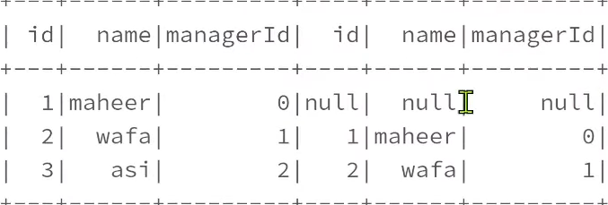 maheer has no manager so it shows null. Wafa has manager id 1 and manager details of wafa is maheer shown. Asi manager id is 2 and asi manager name wafa is shown here.

If I want to take only employee name and manager name column, then

from pyspark.sql.functions import col

df.alias(‘empData’).join(df.alias(‘mgrData’),\

col(‘empData.managerId’)==col(‘mgrData.id’) \

,’left’) \

.select(col(‘empData.name’).alias(‘empName’),col(‘mgrData.name’).alias(‘mgrName’)).show()

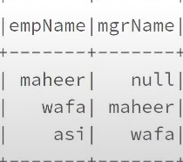

For maheer there is no manager, so it is null in above table.

**pivot() FUNCTION IN PYSPARK:**



How to pivot data frame?

pivot() function used to convert columns data into different columns Eg: assume we have a column called gender in which we have multiple rows where we have like male and female information. We want to convert this male and female as a new columns (individual columns) then we have to use a pivot function. pivot function can be applied on top of the grouped data because we have multiple columns with same values multiple times . so we will be grouping them and then we will be converting that individual column values into separate columns all together.

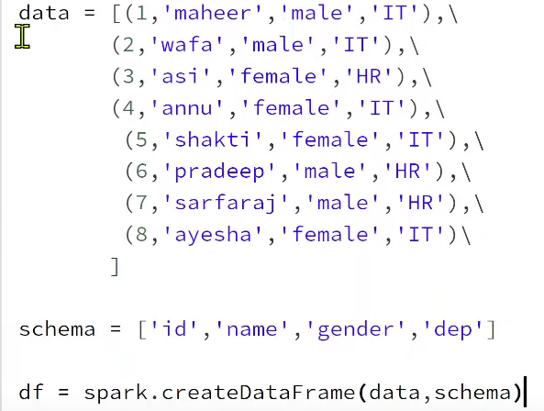

**df.show()**

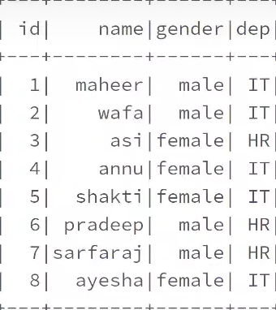

df.groupBy(‘dep’,’gender’).count().show()

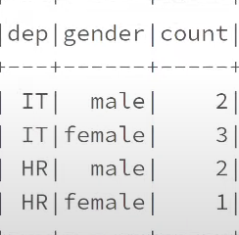

Now I don’t want gender column .what I want is male column and female column. Under male column for it employees what is the count. Under female column for it employees what is the count.

If we want like table schema structure as below: male and female values are coming from gender column, and which came as a pivoted fashion. i.e., rows became columns here we need to use below code in order to get that.

|  |  |  |
| --- | --- | --- |
| dep | male | female |
| IT | 2 | 3 |
| HR | 2 | 1 |

**df.groupBy(‘dep’).pivot(‘gender’).count().show()**

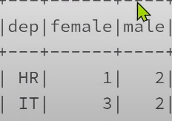 In this example, we have 2 different types of genders male and female that’s why only 2 columns came. In reality let’s assume we have 10 different kinds of rows in some column which we want to pivot then that 10 different types of columns it will create . instead, we may want only few columns then we can name them. For eg gender we are getting 2 columns , we can get only 1 column male , we can go it with below code.

**df.groupBy(‘dep’).pivot(‘gender’,[‘male’]).count().show()**

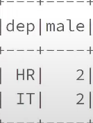

**Unpivot DATAFRAME IN PYSPARK:**



Unpivot function is not available in pyspark . converting column names into rows called unpivot. Using stack function, we can supply number of rows i.e., no of columns we can say , for e.g., if we have 2 columns male and female then that information we have to pass , what is the column and what value we want to convert back into row. For e.g.: for the female column want to convert that into row and in the row, I want to have value like this . When we are converting columns back into rows so what the new column names, we want to get it so for this value ,I want to get gender column and under these columns we may have some data . so, for that data I want to have a count name .

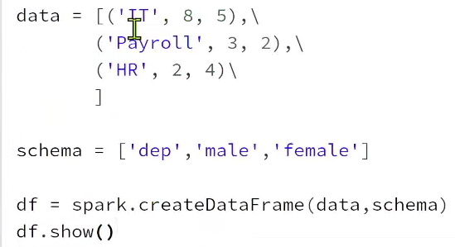

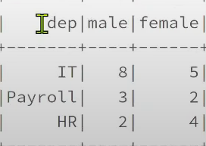 data in male and female are count of male and female in its departments.

Now I want to unpivot this, after unpivot need to get table schema like this .

dep gender count

IT male 8

IT female 5

HR male 2

HR female 4

Column names are converted into rows. We can do this unpivot via below code.

**from pyspark.sql.functions import expr**

**unpivotDf = df.select(‘dep’,expr(“stack(2,’male’,male,’female’,female) as (gender,count)”))**

expr function will take string and that string will be like python code actually. So that string will be treated as a python code or pyspark code and it will be executed as a code not as a string , it won’t treat it as a string .so we can pass our code as a string & data brick cluster will run as a pyspark code only so to do that whenever we want to use some kind of a code to be passed as a string and then dynamically converted that string to code and can execute as a pyspark code. In such scenarios , we have to use this expression function.

We will pass stack function as a string. In stack function , we will supply 2 values , 1st is no of columns unpivoting . here unpivoting 2 columns male and female so mentioned 2 as unpivoted column count and then get value as male wherever we see column name as male i.e., where we have column name as a male that will be converted as a value. For column name we haven’t used single quotes, for values only single quotes was mentioned.

**unpivotDf.show()**

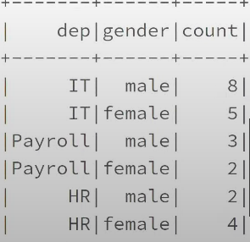

**unpivotDf = df.select(‘dep’,expr(“stack(2,’M’,male,’F’,female) as (gender,count)”))**

wherever I have a male column name take it as a M value. wherever I have a female column name take it as a F value , if we do it

**unpivotDf.show()**

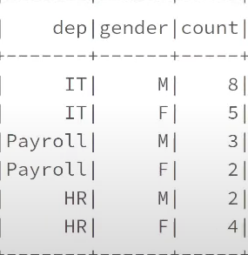

**fill() & fillna() FUNCTION IN PYSPARK:**

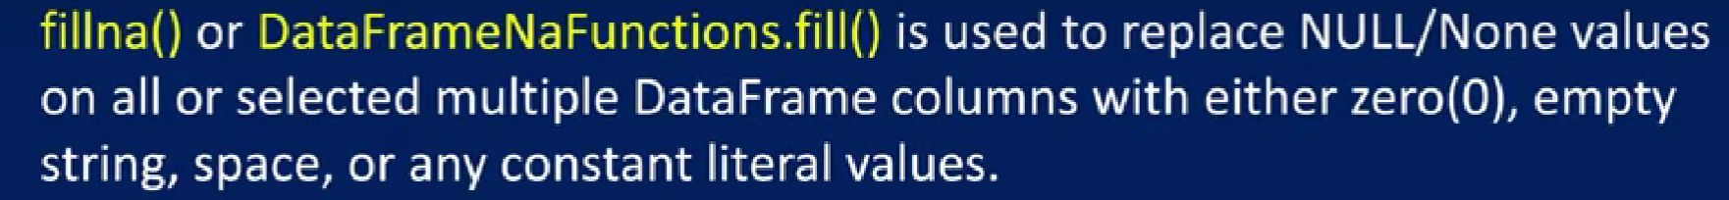

If we have null/none values in our data frame , for some reasons we want to replace them with integer/string/some constant values, then we can use fill() and fillna() functions. Both functions will do same thing

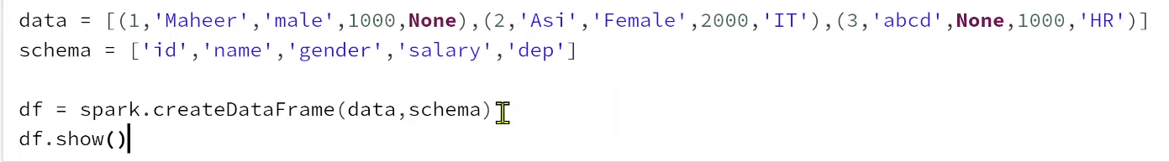

Op:

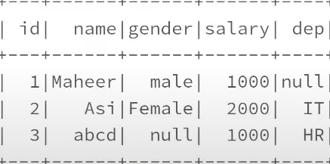

**df.printSchema()**

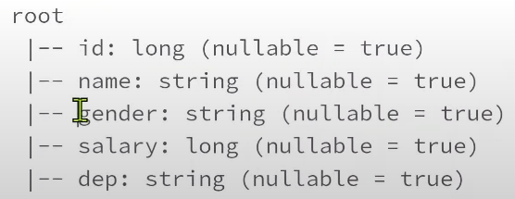

Gender and dep column has null values. Wherever we have string data type , replace nulls/none with some value called unknown may be using fill / fillna

**df.fillna(‘unknown’).show() or df.na.fill(‘unknown’).show()** 🡪 wherever we see N/A or none or null values , it will replaces with unknown value in all columns

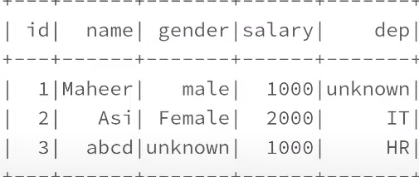

If I want to replace null value to unknown only in gender column, then

**df.fillna(‘unknown’, [‘gender’]).show() or df.na.fill(‘unknown’, [‘gender’]).show()**

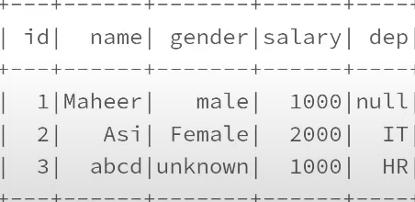

**df.fillna(‘unknown’, [‘gender’,‘dep’]).show() or df.na.fill(‘unknown’, [‘gender’,‘dep’]).show()**

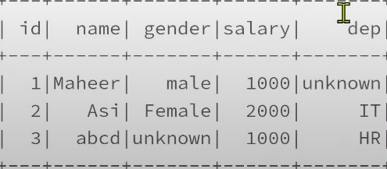

**sample() FUNCTION IN PYSPARK:**



If we have big data set and we want to perform some transformations on it but may be if we want to take some sampling data only to do that testing. Whenever we get any such need where from large dataset, we want to take sample set of rows randomly and then take that sample for testing or anything.in such scenarios , we have to use this sampling function.

Sample function will get us random sampling subset of data from our entire data set.

Sample function has first parameter as fraction. For that fraction, we can pass values between 0 to 1. 0.1 means 10% of rows. 1 means 100% of rows. 0.2 means 20% of rows .

2nd parameter is seed where we can pass any random number as a seed number and that seed number will help us to get fixed set of random rows as a dataset from entire large data set.

Eg:

**df = spark.range(start=1,end=101)** 🡪 we will specify starting and ending values here. From starting value 1 it will increment by 1 up to 101 and it will create that entire as a rows in a data frame.

**display(df)**

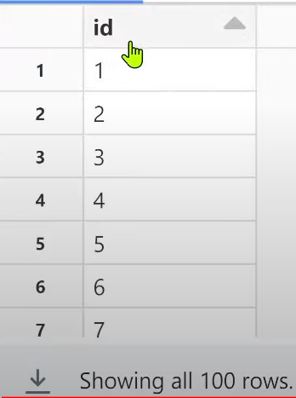

Data frame is created which has id as a column and has 100 rows from id 1 to 100.

Sample function whenever we send some fraction to it ,it won’t guarantee same set of rows it will return and also it wont exactly get the 10% . it may be slightly high or slightly low or may be sometimes exactly 10%

df1= df.sample(fraction =0.1)

display(df1)

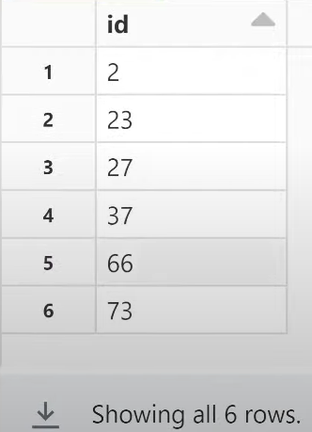 even we specified fraction =0.1 , we get only 6 rows , so its not always same 10 rows.

If we rerun again code , this time we can get 7 rows . this fraction will define percentage of rows to return but it is not guaranteed exact percentage of rows .

df2= df.sample(fraction =0.1)

display(df2)

now if we rerun sample values in df1 and df2 will also differ . values what we get when we use sample function is not constant so there will be random numbers . so, we can’t guarantee this time we got 78, the same row should come in the next row also. There is no such guarantee . for some reason in real time, we may face a scenario where we want to get guaranteed set of random rows so that maybe we are testing something on top of it, same set of rows should come everytime to make sure my functionality is working good because we are testing something there. If such requirement comes what we have to do is we have to pass some seed value here

df1= df.sample(fraction =0.1,seed=123)

df2= df.sample(fraction =0.1,seed=123)

display(df1)

display(df2)

if we see below result, samples what we get is same.

Seed value will help us to get fixed set of rows using sample function from larger data set.

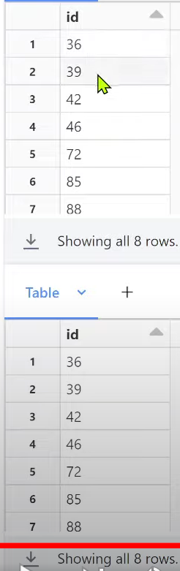

**collect() FUNCTION IN PYSPARK:**

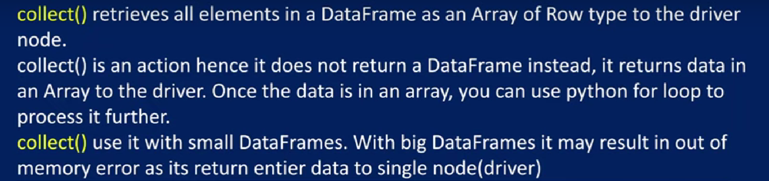

collect function will actually retrieve all the data frame rows as an array onto a single driver node.

collect() function won’t return back us a data frame . it will return us array of data frame rows as row objects

data =[(1,’maheer’,2000),(2,’wafa’,3000)]

schema = [‘id’,’name’,’salary’]

df = spark.createDataFrame(data,schema)

df.show()

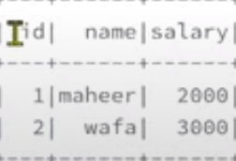

Collect function which is an action type that will return back a array of rows or list of rows.

listRows = df.collect()

print(listRows) 🡪 entire list printing

op:



We have 2 rows only in data frame, so 2 row objects was created in list.

If I want to access 1st row , 1st row/item will be at zero index we can access items inside list via index.

print(listRows[0]) 🡪will give us first item from the list i.e., 1st row (list of 0th index).

Op:



Again in 0th index, I want to access name , name is at 1st index then we can do it via below code.

print(listRows[0][1]) 🡪 this will give second item from the first row.

print(listRows) 🡪 this will give entire list

print(listRows[0]) 🡪 this will give us first item from the list i.e., 1st row.

print(listRows[0][1])🡪 this will give second item from the first row. i.e., 2nd column value from the first row.

Op for 3 print statements:

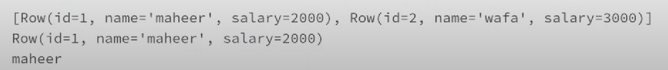

print(listRows[0][0]) op: 1

collect function will return back us array of the row objects since it is not creating any new data frame, so this is an action type actually. Data will be collected on to a single driver node and returned back . collect function is not good practice to use if data frame/data sets is very huge because entire data has to be collected on to a single node(driver node) which is a over burden. Sometimes we will get out of memory errors if we use this collect function on top of the big data sets

**DataFrame.transform() FUNCTION IN PYSPARK:**



Eg: data = [(1,’maheer’,2000),(2,’wafa’,3000)]

schema =[‘id’,’name’,’salary’]

df = spark.createDataFrame(data,schema)

df.show()

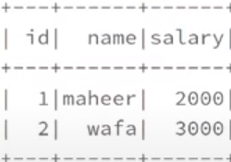

Now I want to apply transformation to convert this column into capitals.

from pyspark.sql.functions import upper

df.withColumn(‘name’,upper(df.name)).show()

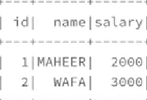

Now here we are defining function by passing parameter as df and returning data frame result.

from pyspark.sql.functions import upper

def convertNameToUpper(df):

return df.withColumn(‘name’,upper(df.name))

Now using transform function ,to transform function you can pass custom transformation name or custom function name which we created.

df1= df.transform(convertNameToUpper) 🡪 this will convert name column to upper cases and return back the data frame. That returned back data frame storing in data frame called df1.

df1.show()



def doubleThesalary(df):

return df.withColumn(‘salary’,df.salary *2)

df2 = df1.transform(doubleThesalary)

df2.show()

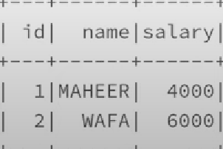

**What if we want to apply multiple transformations in single data frame?**

from pyspark.sql.functions import upper

def convertNameToUpper(df):

return df.withColumn(‘name’,upper(df.name))

def doubleThesalary(df):

return df.withColumn(‘salary’,df.salary *2)

df1=df.transform(convertNameToUpper) \

.transform(doubleThesalary)

df1.show()



**pyspark.sql.functions.transform() function in pyspark:**

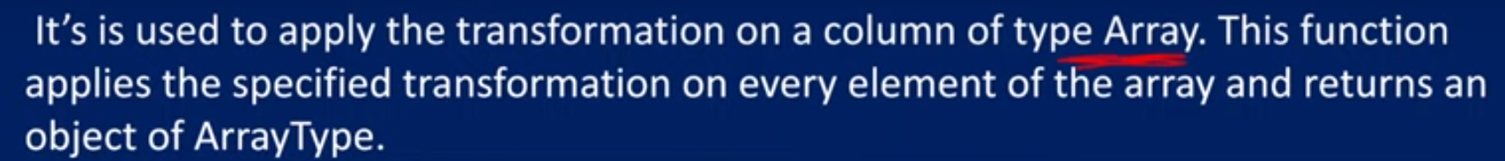

This function used to apply transformation on a column of array type.

Eg:

data =[(1,’maheer’,[‘azure’,’dotnet’]),(2,’wafa’,[‘aws’,’java’])]

schema =[‘id’,’name’,’skills’]

df= spark.createDataFrame(data,schema)

df.show()

df.printSchema()

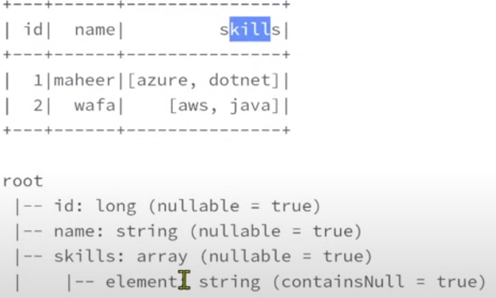

If we want to apply transformation on array type column by changing array column data to capital letters, then

from pyspark.sql.functions import transform,upper

df.select(‘id’,’name’,transform(‘skills’,lambda x:upper(x)).alias(‘skills’)).show()

we are transforming skills column(array type column here). lamda we are creating small function inside and to the lamda function every row /every element of the particular skill column will be passed. i.e; in the first iteration [azure,dotnet] will be passed and in the 2nd iteration [aws,java] will be passed.Every element whatever we pass that we have to define by some variable say x . lamda x means inside a function it is passing x and x will hold [azure,dotnet] and [aws,sql]. First time it will hold [azure,dotnet] and 2nd time it will hold [aws,sql].

Once we go inside a function , we will define a logic , want to convert array type data to capitals.

Defined transform function .transform in above code to take a skills array and then created lamda function small inline function which takes every row/every element of that column and converts it to upper . once transform function execution completes we can give alias name for that column.

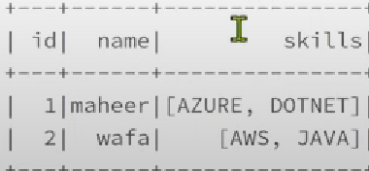

Or we can also do this in other way.

convertArrayToUpper is function name and to this function every element will be passed . creating variable or argument denoted as x that takes every element of the array type column then inside the function it is simply going to return array type value converting to upper case.

def convertArrayToUpper(x):

return upper(x)

df.select(‘id’,’name’,transform(‘skills’, convertArrayToUpper)).show()

the below table shows lambda function and lambda variable. The above code converted the function to lambda function and lambda variable.

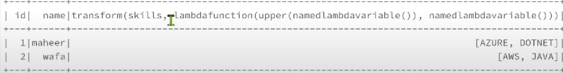

df.select(‘id’,’name’,transform(‘skills’, convertArrayToUpper).alias(‘skills’)).show()



**createOrReplaceTempView() function in pyspark**

we can create a temporary view within the spark session so that we can use SQL queries to perform our data manipulations . If we want to do transformations in SQL , then we can use this createOrReplaceTempView() function. Once data frame created , on top of the data frame it will create like a table, but it is not a physical table .it will be with in the memory within the same session only. Once the session ends then other session people cannot access that particular view . its like a dummy table within the session available for us. We can create sql queries directly on that temp table.

Eg: data =[(1,’maheer’,2000),(2,’wafa’,3000)]

schema =[‘id’,’name’,’salary’]

df= spark.createDataFrame(data,schema)

df.show()

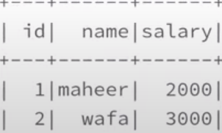

df.createOrReplaceTempView(‘employees’)

df1=spark.sql(“SELECT id,name FROM employees”)

df1.show()

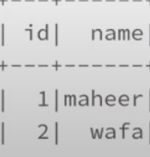

We can also do it with magic command as shown below.

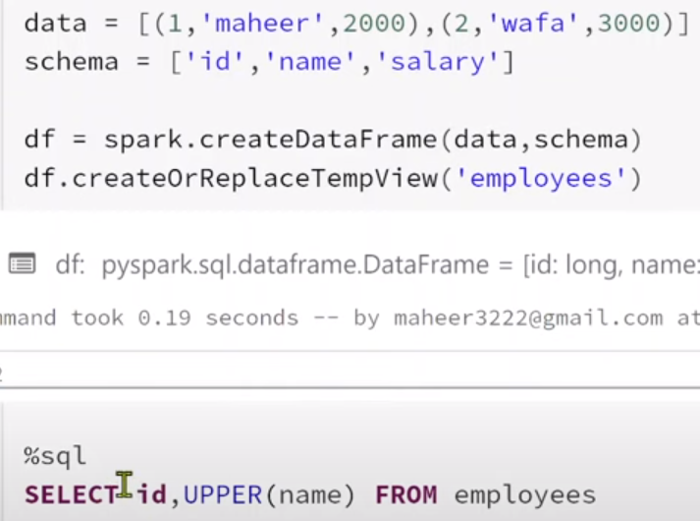

Op:

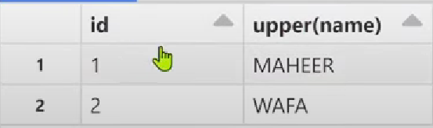

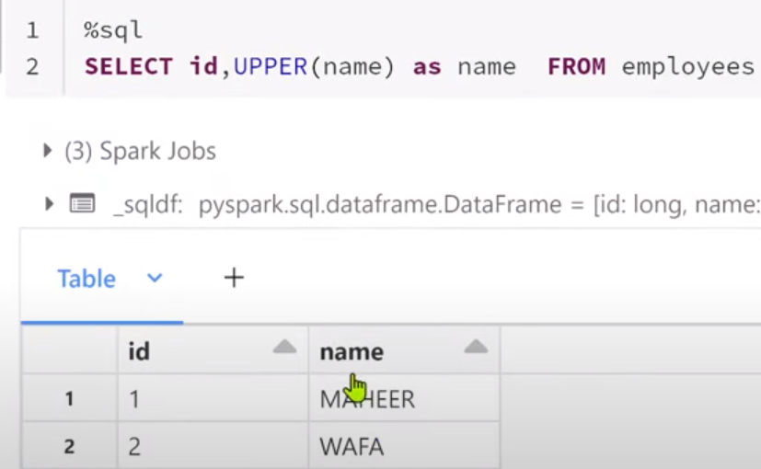

**createOrReplaceGlobalTempView() function in pyspark**

TempViews are session level, but this GlobalTempViews can be accessed across the sessions between the spark application .whenever we create one notebook in databricks and then when we start writing spark code so its like one session .Lets assume we created another notebook attached with the same cluster then its like another session . we created 1 temporary view in notebook1 ,then within that session it will be available . we cannot access that temporary view in notebook2.

If we create a global temporary view ,then that can be accessed on across the sessions within the same spark context or same spark application .

%scala

spark

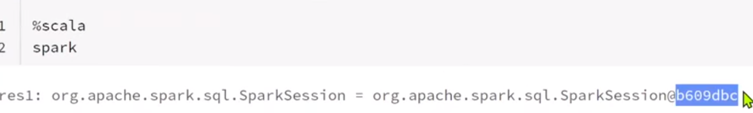

We can get spark session id (b609dbc) from scala as shown above.

Now we will create notebook2 and run same command

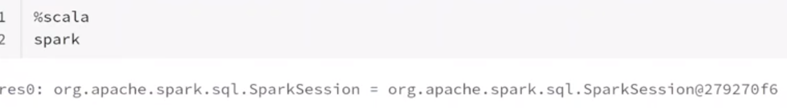

Sessionid for notebook2 is different 279270f6 from notebook1 session id b609dbc even if both notebooks are running on same cluster i.e; like a same spark application .

Notebook1:

data=[(1,’maheer’),(2,’wafa’)]

schema=[‘id’,’name’]

df=spark.CreateDataFrame(data,schema)

df.show()



df.createOrReplaceTempView(‘emp’)

%sql

Select * from emp 🡪 we will get data.

In Notebook2 , if we run

%sql

Select * from emp 🡪 we will get error as table or view doesn’t exist.

Notebook1:

df.createOrReplaceGlobalTempView(‘empGlobal’)

%sql

Select * from global_temp.empGlobal 🡪 All global tables will be saved in global_temp

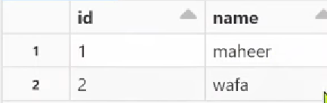

Notebook2 :

%sql

Select * from global_temp.empGlobal



i.e; Global temporary views are accessible across the sessions

**To View global temp tables in spark applications:** we need to do below query. On top of spark we will do catalog information i.e; application information . on top of application/catalog information, we can use listTables function to list down the tables . so, to the listed tables we are passing global_temp data base name /name space name so that we can view my global temporary tables also.

spark.catalog.currentDatabase() 🡪 this will give current session data base.

Op: 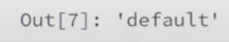

spark.catalog.listTables(‘default’)



spark.catalog.listTables(‘global_temp’)



If we go to notebook2 , if we run same query,

spark.catalog.listTables(‘global_temp’)



If we want to drop TempViews , then we can use below query.

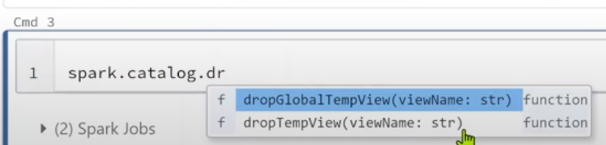

spark.catalog.dropGlobalTempView(‘empGlobal’)

**UDF (user defined function in PySpark):**

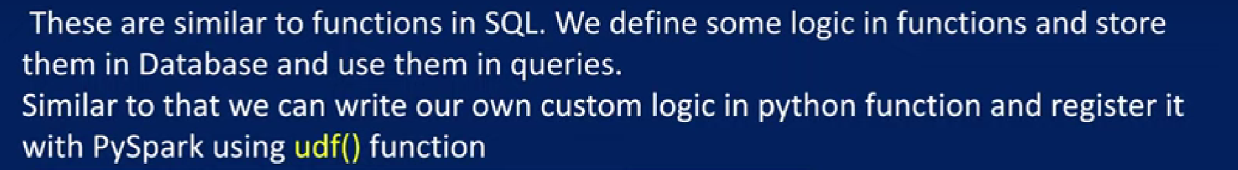

data =[(1,’maheer’,2000,500),(2,’wafa’,4000,1000)]

schema =[‘id’,’name’,’salary’,’bonus’]

df=spark.createDataFrame(data,schema)

df.show()

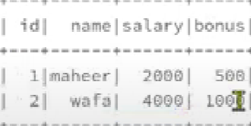

def totalPay(s,b):

return s+b

once function is ready , we will register it using udf function

from pyspark.sql.functions import udf

from pyspark.sql.types import IntegerType

TotalPayment=udf(lambda s,b:totalPay(s,b),IntegerType())

Now with TotalPayment name , function is available in pyspark.

df.withColumn(‘totPay’,TotalPayment(df.salary,df.bonus)).show()

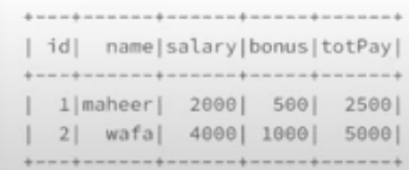

Note: what we did is we used our logic in a python function and registered using UDF function .

We can also register using other way using annotation function @udf() as shown below:

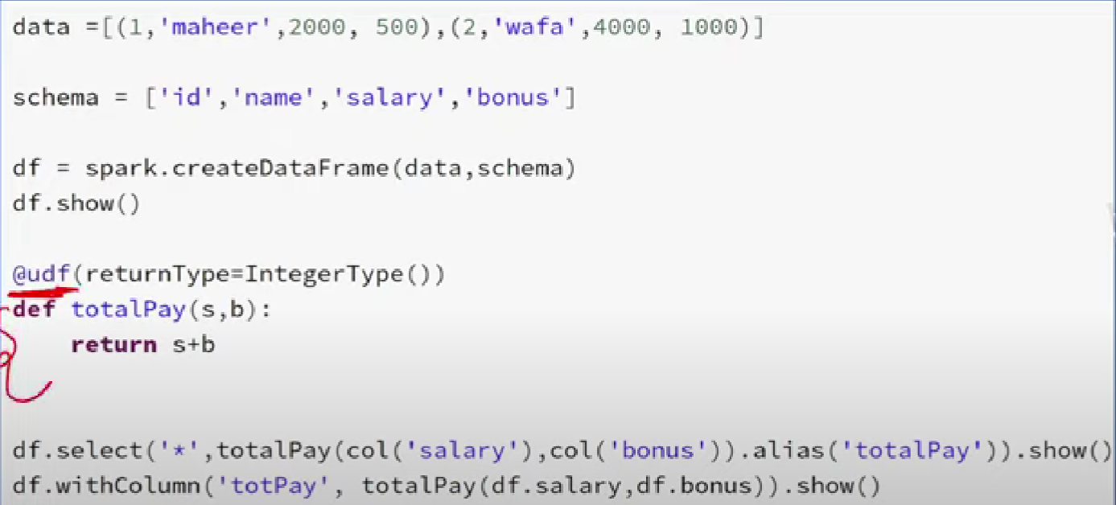

We can also register via other way as shown below.

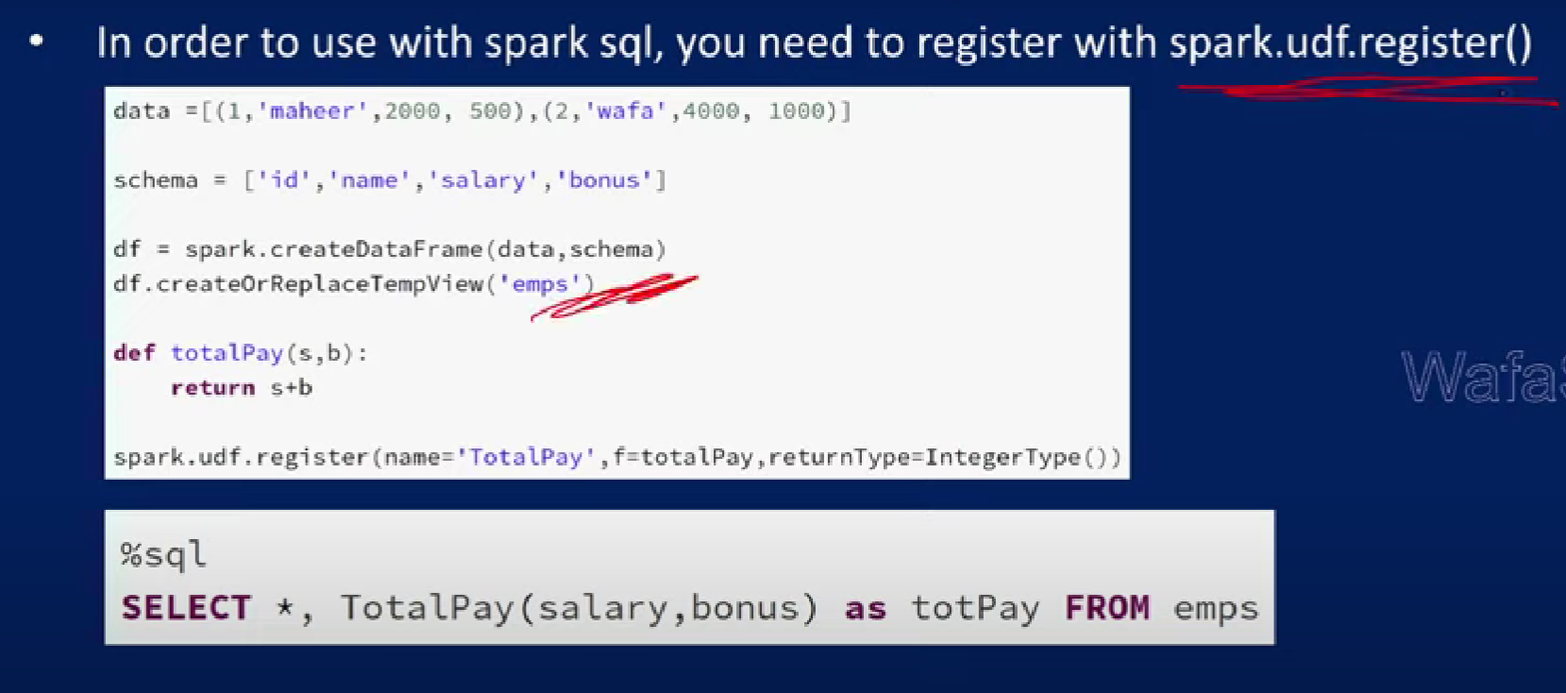

**Convert RDD to Dataframe:**

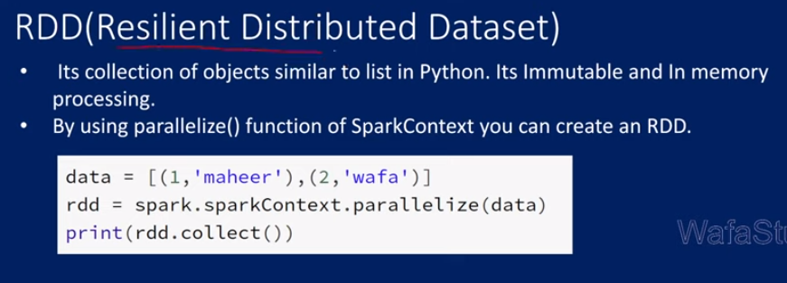

Immutable means Whenever we apply transformation on top of the data frame, it wont change it will create a new data frame that is called immutable nature. We cannot change once it is created.it can create the new one with the new changes but we cannot change the existing one and it will process everything in the memory . In RDD if we have 10 objects, the objects will be partitioned & they were distributed to the individual nodes on the cluster to process them and then finally grouped together to produce the data for us . so that distribution and then processing nature will be there and it is a fault tolerance i.e., if any particular node fails, rdd object will be recovered back .

To create rdd object , we should use spark context class on which there is a function called parallelize that will create a rdd object from the list .

Eg: data=[(1,’maheer’),(2,’wafa’)]

print(type(data))

op: <class ‘list’>

now this list we will convert as a rdd object . to do that on top of spark session object there is sparkContext instance on which there is a parallelize function. To this function we can pass this list to create a rdd object and result stored in rdd variable.

rdd=spark.sparkContext.parallelize(data)

print(type(rdd))

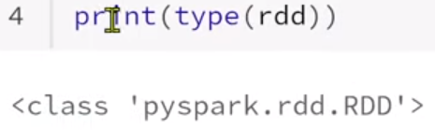 🡪 print statement tells us that it is a rdd type object.

print(rdd.collect())

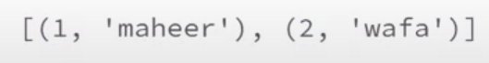

We can convert rdd to data frame by using rdd.toDF()

df=rdd.toDF()

df.show()

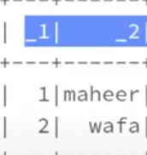

df=rdd.toDF([‘id’,’name’])

df.show()

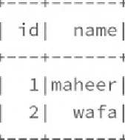

Or we can also use some other syntax,

df1= spark.createDataFrame(rdd,[‘id’,’name’])

df1.show()



**map() transformation in pyspark:**

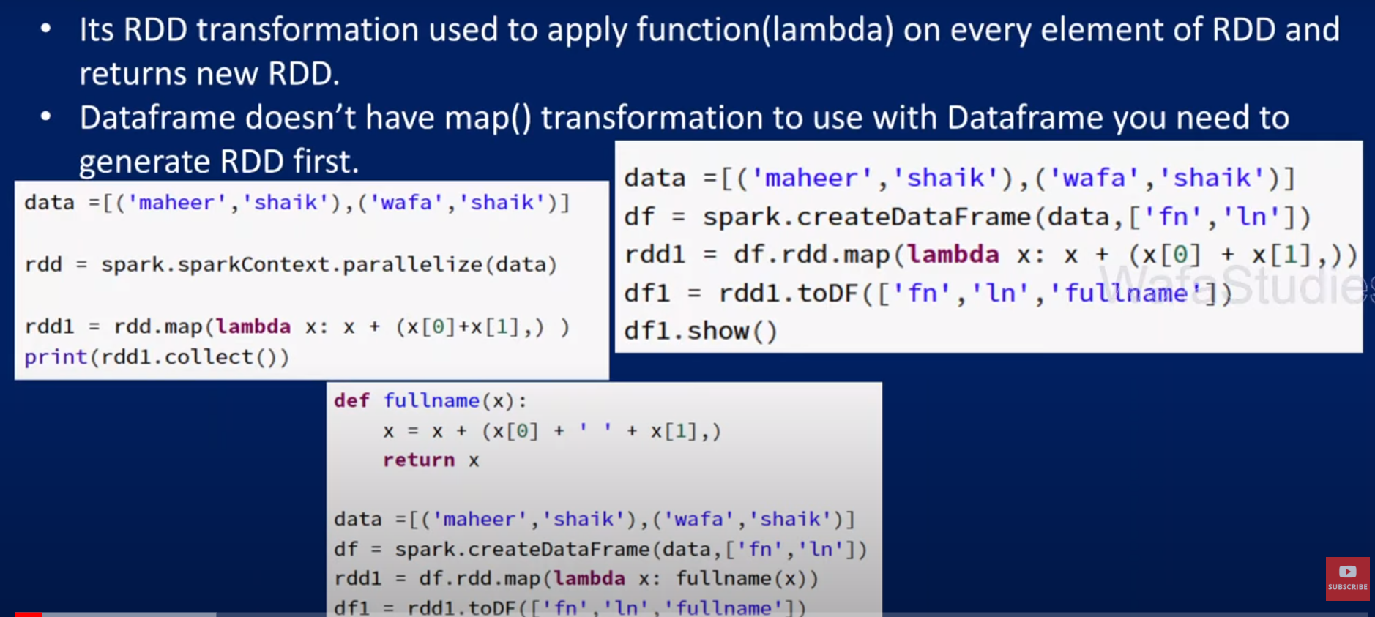

data=[(‘maheer’,’shaik’),(‘wafa’,’shaik’)]

rdd= spark.sparkContext.parallelize(data)

print(rdd.collect())

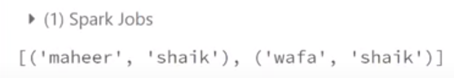

rdd1= rdd.map(lambda x:x + (x[0]+’ ‘+x[1],) )

Explanation of code:

lamda x 🡪 here x point to every item in rdd , i.e; in first iteration it will point to 1st item(‘maheer’,’shaik’), in 2nd iteration it will point to 2nd item(‘wafa’,’shaik’) .

whatever logic written after : that logic will be executed

:x means in existing tuple we are adding new item

+(x[0] + ‘ ‘ + x[1]) 🡪 used for generating full name .

We will use , after that because we need to add the full name in tuple so.

print(rdd1.collect())



--

We can use map function on top of data frames as well as shown below.

data=[(‘maheer’,’shaik’),(‘wafa’,’shaik’)]

df=spark.createDataFrame(data,[‘fn’,’ln’])

df.show()

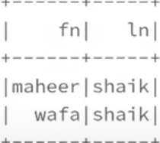

rdd1= df.rdd.map(lambda x:x + (x[0]+’ ‘+x[1],))

Explanation of code:

df.rdd 🡪 used to generate rdd from df using this rdd property.

On top of rdd there is map function(.map) , to the map function we will pass same code as above.

df1=rdd1.toDF([‘fn’,’ln’,’fullname’])

df1.show()

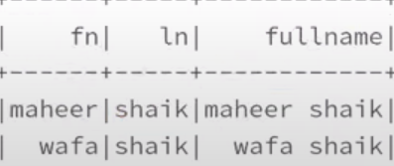

Instead of writing logic every time in lambda, we can def a function and we can write logic there.

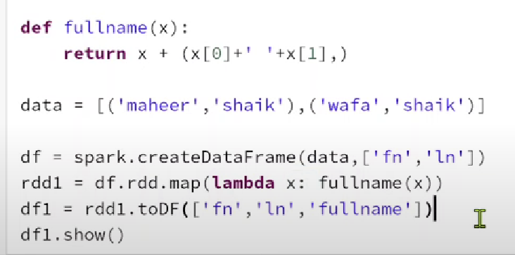



**flatMap() transformation in pyspark:**

